Care Coordination (CC) Standardized Episodes of Care (SEOC)

Software Version 1.8

User Guide



June 2019

Department of Veterans Affairs

Office of Information and Technology (OI&T)

Revision History

NOTE: The revision history cycle begins once changes or enhancements are requested after the document has been baselined.

|  |  |  |  |
| --- | --- | --- | --- |
| Date | Revision | Description | Author |
| 06/11/2019 | 6.0 | Updated for v1.8:   * Draft New SEOC section * Activate an In-Progress SEOC section * Delete an In-Progress SEOC section * Revert SEOC to In-Progress section | AbleVets |
| 3/05/2019 | 5.0 | Updated for v1.7. Added Managing Billing Codes, Updated screen captures to reflect v1.7 | AbleVets |
| 1/02/2019 | 4.0 | Updated for v1.6 Updated screen captures, Added Exporting SEOC Data section, added Appendix A. | AbleVets |
| 10/04/2018 | 3.0 | Updated for v1.5 Included Manage Users features: Filter by Role, Filter by Name, Delete Selected User, Edit Selected User, and Add New User. | AbleVets |
| 09/25/2018 | 2.0 | Finalized for Software Version 1.0.04.1 | AbleVets |
| 09/14/2018 | 1.3 | Finalized for Build 5 | AbleVets |
| 08/09/2018 | 1.2 | Updated for Build 5 | AbleVets |
| 07/20/2018 | 1.1 | Updated for Software Version 1.0.4 Build 4 | AbleVets |
| 06/25/2018 | 1.0 | Initial Draft Delivery | AbleVets |

**Artifact Rationale**

Per the Veteran-focused Integrated Process (VIP) Guide, the User’s Guide is required to be completed prior to Critical Decision Point #2 (CD2), with the expectation that it will be updated as needed. A User Guide is a technical communication document intended to give assistance to people using a particular system, such as VistA end users. It is usually written by a technical writer, although it can also be written by programmers, product or project managers, or other technical staff. Most user guides contain both a written guide and the associated images. In the case of computer applications, it is usual to include screenshots of the human-machine interfaces, and hardware manuals often include clear, simplified diagrams. The language used is matched to the intended audience, with jargon kept to a minimum or explained thoroughly. The User Guide is a mandatory, build-level document, and should be updated to reflect the contents of the most recently deployed build. The sections documented herein are required if applicable to your product.

**Table of Contents**

1. Introduction 1

1.1. Purpose 1

1.2. Document Orientation 1

1.2.1. Organization of the Manual 1

1.2.2. Assumptions 2

1.2.3. Coordination 2

1.2.4. Disclaimers 3

1.2.4.1. Software Disclaimer 3

1.2.4.2. Documentation Disclaimer 3

1.2.5. Documentation Conventions 3

1.2.6. References and Resources 3

1.3. National Service Desk and Organizational Contacts 3

2. System Summary 3

2.1. System Configuration 4

2.2. Data Flows 5

2.3. User Access Levels 5

2.4. Continuity of Operation 6

3. Getting Started 6

3.1. Logging On 6

3.2. System Menu 7

3.3. Changing User ID and Password 8

3.4. Exit System 8

4. Using the Software 8

4.1. Manage Users 9

4.1.1. Viewing SEOC Users 9

4.1.1.1. Filtering Users 9

4.1.2. Delete a Selected User 10

4.1.3. Edit a Selected User 10

4.1.4. Add a New User 11

4.2. Managing Billing Codes 12

4.2.1. Deleting Billing Codes 13

4.2.2. Editing Billing Codes 14

4.3. View SEOCs 15

4.3.1. View a Selected SEOC 15

4.3.2. Search for a SEOC by Name 16

4.3.3. Filter SEOCs by Status 17

4.3.4. Discontinue a SEOC 17

4.3.5. Print a SEOC 18

4.3.6. Track Version Changes 19

4.4. Draft a New SEOC 20

4.4.1. Edit an In-Progress SEOC 30

4.4.2. Activate an In-Progress SEOC 30

4.4.3. Delete an In-Progress SEOC 31

4.5. Pending Revisions 31

4.5.1. Create a Pending Revision 31

4.5.2. Activate a Pending Revision 35

4.5.3. Revert SEOC to In-Progress 36

4.6. Payable Service List 37

4.6.1. View Payable Services 37

4.6.2. Delete Payable Service 37

4.7. Exporting SEOC Data 38

5. Troubleshooting 38

6. Acronyms and Abbreviations 39

A. JSON Instructions 40

List of Figures

Figure 1: Overview of SEOC System 4

Figure 2: SEOC Data Flow Diagram 5

Figure 3: VA Single Sign-On for SEOC 6

Figure 4: 2 Minutes Until Session Expires Warning 7

Figure 5: Standardized Episodes of Care Home Page 7

Figure 6: User Management 9

Figure 7: Filtered List by Name Example 10

Figure 8: Delete Selected User Confirmation 10

Figure 9: Editable User Fields 11

Figure 10: Add New User Fields 12

Figure 11: Billing Code Management 13

Figure 12: Confirm Delete Billing Code Message 13

Figure 13: Edit Billing Code 14

Figure 14: Edit Billing Code Confirmation Message 15

Figure 15: Standardized Episode of Care – Provider Information 16

Figure 16: SEOC Filter Field 16

Figure 17: Search SEOC Results 17

Figure 18: Filter by Status Menu Options 17

Figure 19: Discontinue SEOC Confirmation 18

Figure 20: Discontinued Status 18

Figure 21: Printed SEOC Window 19

Figure 22: Tracked Version Changes 20

Figure 23: Draft SEOC: Name 20

Figure 24: Draft SEOC Details 21

Figure 25: Add/Remove HPTCs 22

Figure 26: Provider Taxonomy Code List 22

Figure 27: Selected HPTC 23

Figure 28: Draft SEOC: Payable Services 24

Figure 29: Draft SEOC: Add Payable Service 24

Figure 30: Manage Clinical Services for Payable Service 25

Figure 31: Clinical Service Field 26

Figure 32: Draft SEOC: Add Billing Code 27

Figure 33: Define New Code 27

Figure 34: Duplicate Billing Code Message 28

Figure 35: Billing Code 28

Figure 36: Payable Services 29

Figure 37: Draft SEOC View 29

Figure 38: SEOC Activation Effective Date 30

Figure 39: Activation Status 31

Figure 40: Confirm Deletion 31

Figure 41: Pending Revision: Name 32

Figure 42: Pending Revision: Details 33

Figure 43: Pending Revision: SEOC Provider Taxonomy Codes 33

Figure 44: Pending Revision: Payable Services 34

Figure 45: Pending Revision Status 34

Figure 46: Pending Revision Displayed in SEOC List 35

Figure 47: Pending Revision Activation Confirmation Message 35

Figure 48: Date Hold Status 36

Figure 49: Revert SEOC to In-Progress 36

Figure 50: Standardized Episode of Care – Payable Services 37

Figure 51: Payable Service Confirm Deletion 38

Figure 52: Export SEOC Download Message 38

Figure 53: Import Data Window 40

Figure 54: Query Editor 41

Figure 55: List of Records 41

Figure 56: To Table Dialog Box 42

Figure 57: Search Columns to Expand Dialog Box 42

Figure 58: Search Columns to Expand 43

Figure 59: Expanded SEOC Fields 44

Figure 60: Expand to New Rows Menu Option 44

Figure 61: Payable Services Columns 45

Figure 62: Billing Code Columns 45

Figure 63: Expanded HPTC Fields 46

Figure 64: Imported Data 46

# Introduction

The Care Coordination (CC) Standardized Episodes of Care (SEOC) is a reference database for managing care bundles for use by Veterans Information Systems and Technology Architecture (VistA) and other Department of Veterans Affairs (VA) systems. Services are grouped together within the SEOC system into bundles so that clinicians can add these bundles to patients consult records in a standardized fashion, reducing the amount of time spent manually entering consult instructions, and providing uniformity among the patient records and across facilities for how patient care is prescribed for similar complaints.

These bundles group together one or more services that are preselected for different specialties to be added to the consult records. In addition, the clinician is provided with information regarding prescribing rules and preauthorization requirements, so they can make the most informed decisions regarding patient care.

Additionally, SEOC data will be accessible outside of the VistA/Computerized Patient Record System (CPRS) system so that users of downstream applications will be accessing the centralized data, and SEOC descriptions, reducing the chances of disconnects.

## Purpose

The purpose of this document is to provide instruction for utilizing the SEOC application to standardize and streamline consult management for Community Care.

## Document Orientation

The *Care Coordination (CC) Standard Episodes of Care (SEOC) v1.8.0 User Guide* will provide explanations of each screen and of all user interface options within the context of an easy to understand demonstration data scenario.

This document is also designed to provide the user with screen-by-screen “how to” information on the usage of CC SEOC.

### Organization of the Manual

**Section 1: Introduction**

The Introduction section provides the purpose of this manual, an overview of the SEOC software, an overview of the software used, project references, contact information for the user to seek additional information, and an acronyms and abbreviations list for this manual.

**Section 2: System Summary**

The System Summary section provides a graphical representation of the equipment, communication, and networks used by the system, user access levels, how the software will be accessed, and contingencies and alternative modes of operation.

**Section 3: Getting Started**

Information for the Getting Started section provides a general walk-through of the system from initiation through exit, enabling the user to understand the sequence and flow of the system.

**Section 4: Using the Software**

This section gives the user the “how to” information to use SEOC, including many step-by-step procedures.

**Section 5: Troubleshooting**

This section provides troubleshooting for the SEOC user.

**Section 6: Acronyms and Abbreviations**

This section provides a list of acronyms and abbreviations found in this document.

### Assumptions

This guide was written with the following assumed experience/skills of the audience:

* The SEOC user has basic knowledge of the SEOC system (such as the use of commands, menu options, and navigation tools).
* The SEOC user has been provided the appropriate active roles, menus, and security keys required for the SEOC User Interface (UI), as defined below in User Roles.
* The SEOC user is using SEOC to perform their daily consult creation workflow and perform the required SEOC functions.
* The SEOC user has validated access to the SEOC UI.
* The SEOC user has been provided training on the SEOC UI and has reviewed the User Guide.
* SEOC Content Authors: The SEOC Content Authors are responsible for creating and update the content within the SEOC repository using the SEOC UI. These users are required to VA access rights and privileges and will sign on to the SEOC application using their SSOI credentials (typically their PIV and access code).
* CPRS Clinicians that are responsible for documenting patient consult records. These clinicians utilize the SEOC content as part of their daily consult creation workflow such that they will add a SEOC bundle to the patient consult record which will provide for a standardized documentation and care plan approach across the VA for these consults.

### Coordination

One Consult - Consult Toolbox 1.9.02 and above and the HealthShare Referral Manager (HSRM) depend on the availability of the SEOC System. Consult Toolbox 1.9.02 requires active SEOCs whereas HSRM requires active and discontinued SEOCs. Coordination between the One Consult – Consult Toolbox, HSRM, and SEOC team is necessary with any updates to SEOC.

### Disclaimers

#### Software Disclaimer

This software was developed at the Department of Veterans Affairs (VA) by employees of the Federal Government in the course of their official duties. Pursuant to title 17 Section 105 of the United States Code this software is not subject to copyright protection and is in the public domain. VA assumes no responsibility whatsoever for its use by other parties, and makes no guarantees, expressed or implied, about its quality, reliability, or any other characteristic. We would appreciate acknowledgement if the software is used. This software can be redistributed and/or modified freely provided that any derivative works bear some notice that they are derived from it, and any modified versions bear some notice that they have been modified.

#### Documentation Disclaimer

The appearance of external hyperlink references in this manual does not constitute endorsement by the Department of Veterans Affairs (VA) of this Web site or the information, products, or services contained therein. The VA does not exercise any editorial control over the information you may find at these locations. Such links are provided and are consistent with the stated purpose of the VA.

### Documentation Conventions

This manual uses several methods to highlight different aspects of the material.

Table 1. Documentation Symbols and Descriptions

|  |  |
| --- | --- |
| Symbol | Description |
| Triangle with an exclamation point (!) inside to indicate caution for the reader to take special notice of critical information. | **CAUTION:** Used to caution the reader to take special notice of critical information. |

1. Notes are used to inform the reader of general information including references to additional reading material.

### References and Resources

Readers who wish to learn more about CPRS and CC SEOC should consult the [VA Software Document Library](https://www.va.gov/vdl/).

## National Service Desk and Organizational Contacts

For issues related to the CC SEOC that cannot be resolved by this manual or the site administrator, please contact the National Service Desk at 855-NSD-HELP (673-4357).

# System Summary

There was an immediate need to provide clinicians the ability to quickly and consistently add care bundles to a patient’s consult record within VistA. SEOC provides this feature for a higher level of uniformity in patient care, easier access to appropriate services, based on initial diagnoses, and the ability to better control care costs. SEOC allows clinicians to enhance the coordination of care for the Veteran.

The system contains SEOCs, or care bundles, that clinicians or other designated individuals can assign to VA patients. These bundles allow for the consistent use of procedures when certain conditions are diagnosed. This consistency allows the VA to effectively manage patient care and provides easier traceability.

## System Configuration

The SEOC System is designed to be a simple reference database with a supporting SEOC API and User Interface (UI) layer. The SEOC system comprises three application tiers as shown below.

Figure 1: Overview of SEOC System

SEOC Figure 1. 
Diagram depicting the 3 tiers of the SEOC system. 

The first tier is the Data Tier. This tier contains SEOC data. SEOC uses Microsoft Structured Query Language (SQL) Server is the database. SEOC data consists of reference data, such as SEOC name, associated procedures, associated Current Procedural Terminology (CPT) codes, procedure durations, etc. Additionally, user role information is maintained within the tables, but no passwords or other credentials are stored. No PHI or PII is stored in the database. SEOC data is associated with patient data in the VistA consult record.

The second tier is the Abstraction Tier. This tier acts as the data broker for the SEOC system. It is a REST Application Programming Interface (API), built as a microservice hosted on container infrastructure (Docker Container). The API itself is built on the Spring MVC framework. The API receives web API calls that are forwarded to the database appropriately. Consuming applications are able to query the SEOC system through the SEOC REST API but will not be able to perform updated operations. The SEOC UI uses certificates to authenticate with the SEOC REST API to allow data modification within the SEOC system by authenticated users. Users are authenticated using SSOI. Additionally, a VistA/MUMPS patch is created to insert the SEOC associations into File # 123.

The third and final tier is the Presentation Tier. This tier consists of the SEOC UI, which provides a user interface for approved, authenticated users to maintain the SEOC collection. This application is a web application built as a microservice hosted on container infrastructure (Docker Container). The UI is built using the React.js JavaScript framework for web applications.

## Data Flows

Figure 2: SEOC Data Flow Diagram

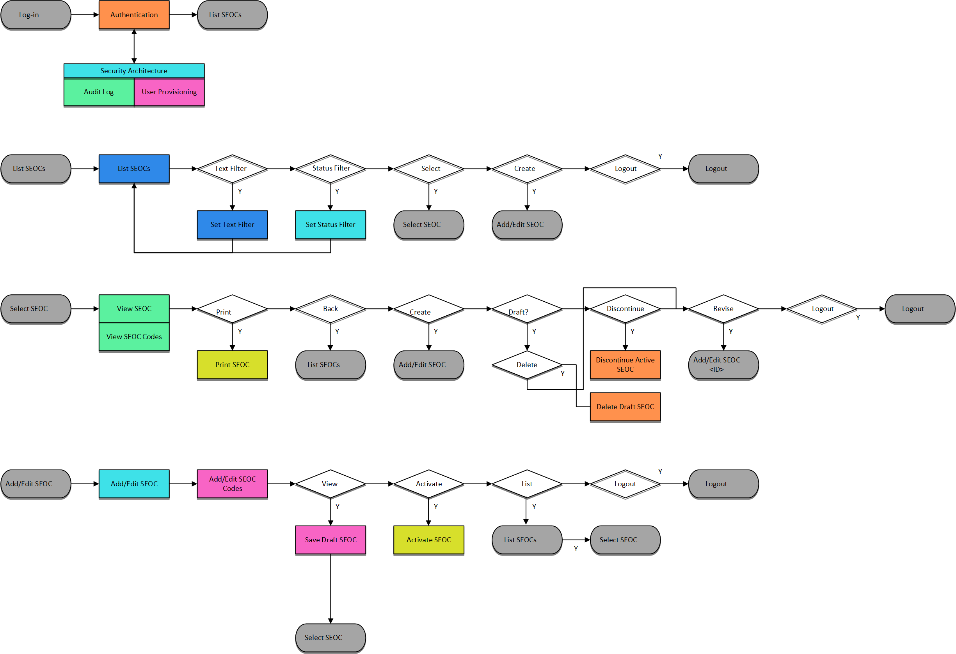

## User Access Levels

SEOC user profiles comprise of the following “types of users”:

* SEOC Content Authors: The SEOC Content Authors are responsible for creating and update the content within the SEOC repository using the SEOC UI. These users are required to VA access rights and privileges and will sign on to the SEOC application using their SSOI credentials (typically their PIV and access code).
* CPRS Clinicians that are responsible for documenting patient consult records. These clinicians utilize the SEOC content as part of their daily consult creation workflow such that they will add a SEOC bundle to the patient consult record which will provide for a standardized documentation and care plan approach across the VA for these consults.
* SEOC data is also accessible to other external consumers in the future (in addition to CPRS users). The SEOC API is a RESTFul API that other (to be determined) users will have access to use.

## Continuity of Operation

The SEOC system is maintained by Enterprise Operations (EO). The continuity of operations is managed by EO.

# Getting Started

This section provides a general walkthrough of CC SEOC from initiation through exit.

## Logging On

CC SEOC is accessed using the VA Single Sign-On Internal (SSOi) log in using the following URL: <https://seoc.va.gov/>

Figure 3: VA Single Sign-On for SEOC

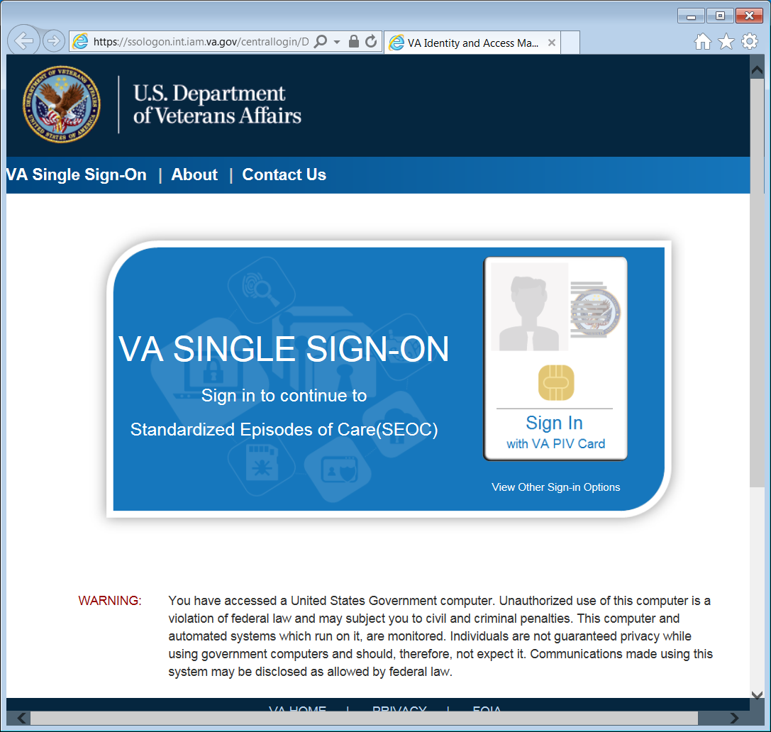

1. After 15 minutes of inactivity the system will automatically log you out. After 13 minutes of inactivity the system will prompt you to extend your session.

Figure 4: 2 Minutes Until Session Expires Warning

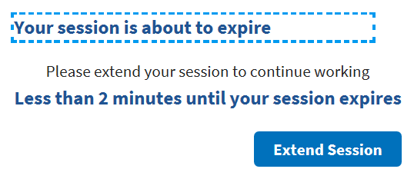

## System Menu

The Standardized Episodes of Care home page offers seven features: **Filter by Status**, **Filter by Name**, **Manage Users**, **Export SEOC Data**, **Manage Billing Codes**, **View Selected SEOC**, and **Draft New SEOC**. The home page also displays the user name at the top right of the page.

Figure 5: Standardized Episodes of Care Home Page

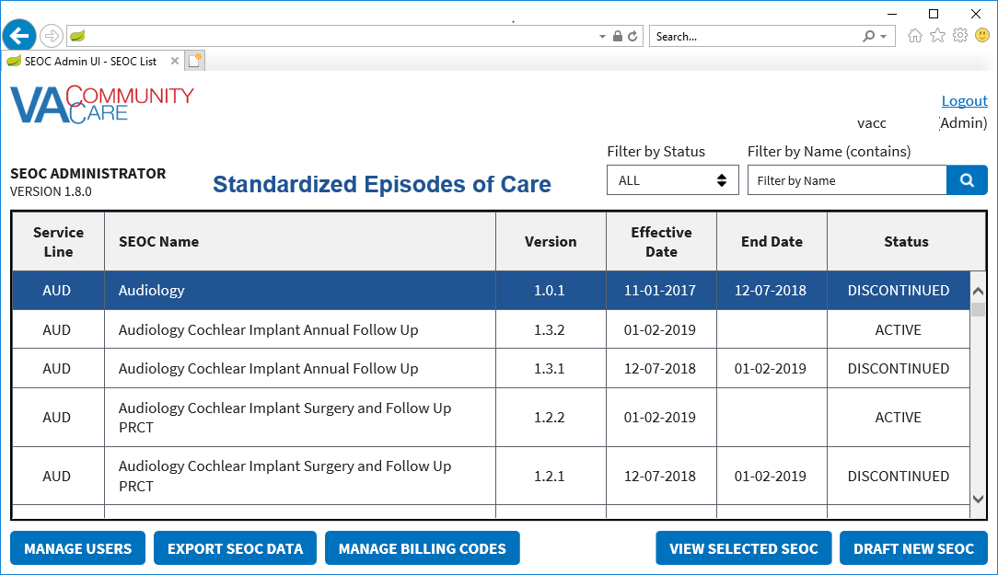

Standardized Episodes of Care table fields:

* **Service Line** – The VA department that is responsible for the type of work authorized by the SEOC.
* **SEOC Name** –The name of the SEOC.
* **Version** –The version number of the SEOC. The version number is formatted A.B.C where the first digit represents the CC Program in effect when the SEOC is first published, the second digit is the number of published SEOCs in the same Category of Care when a new SEOC is activated, and the third digit is a serialized revision number.
* **Effective Date** –The date the SEOC was activated.
* **End Date** –The date the SEOC was discontinued.
* **Status** –The status of the SEOC: **Active**, **Date Hold**, **Discontinued**, or **In-Progress**.

## Changing User ID and Password

If you need to change your user password, you will need to contact your local PIV office.

## Exit System

If you are finished working, log out of VA Single Sign-On and close any secure sessions that may still be open by clicking the **Logout** button.

# Using the Software

The CC SEOC provides user functionality for the following items:

* **Manage Users**
* **Viewing SEOC Users**
  + - Filtering Users
* **Delete a Selected User**
* **Edit a Selected User**
* **Add a New User**
* **Export SEOC Data**
* **Manage Billing Codes**
* **Viewing SEOCs**
* **View a Selected SEOC**
* **Search for a SEOC by Name**
* **Filter SEOCs by Status**
* **Discontinue a SEOC**
* **Print a SEOC**
* **Create a Draft SEOC**
* **Edit a Draft SEOC**
* **Activate a Draft SEOC**
* **Delete a Draft SEOC**
* **Create a Pending Revision**
* **Payable Service List**
* **View Payable Services**
* **Delete Payable Services**

## Manage Users

### Viewing SEOC Users

To view the list of users in SEOC, follow the steps listed below:

1. From the CC SEOC home page, click **Manage Users**. The **User Management** window displays.

Figure 6: User Management

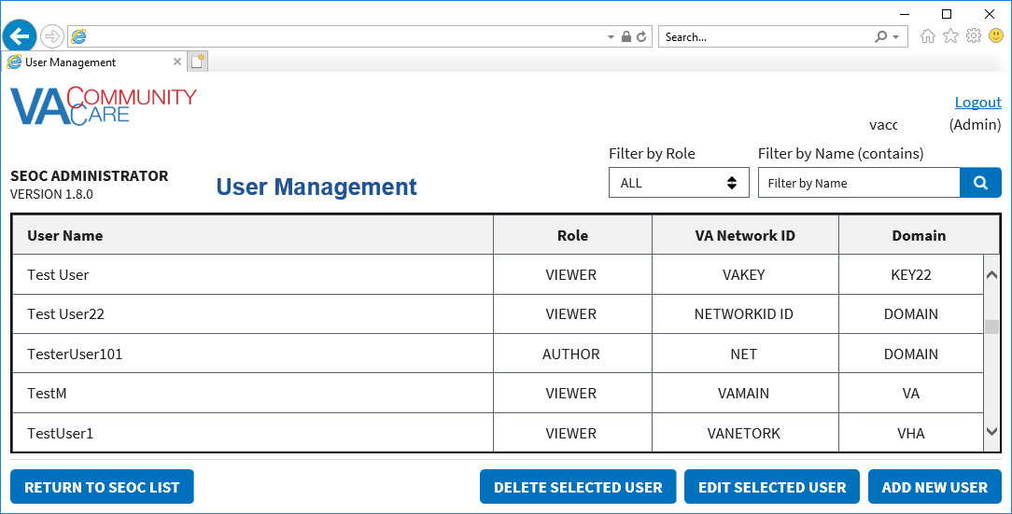

#### Filtering Users

To filter the list of users in SEOC by role or name, follow the steps listed below:

1. From the CC SEOC home page, click **Manage Users**. The **User Management** window displays.
2. To filter the list of users by role, select **All**, **Viewer**, **Analyst**, **Author**, **Publisher**, or **Administrator** from the **Filter by Role** drop-down menu. The list refreshes to display the role selected.
3. To filter the list of users by name, enter the name in the **Filter by Name (contains)** field. The list refreshes to display the name or characters entered in the field.

Figure 7: Filtered List by Name Example

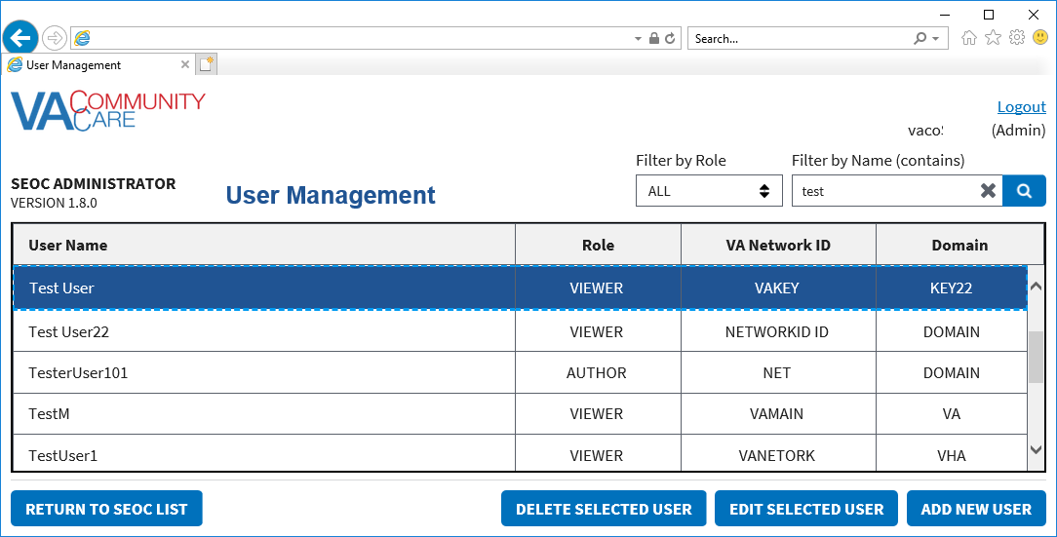

### Delete a Selected User

To delete a user from the User Management list, follow the steps listed below:

1. From the CC SEOC home page, click **Manage Users**. The **User Management** window displays.
2. From the list of users, select the user that you would like to delete.
3. Click **Delete Selected User**. A message displays confirming that you would like to delete the user.

Figure 8: Delete Selected User Confirmation

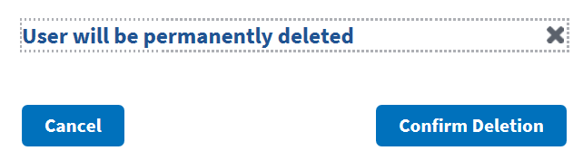

1. Click **Confirm Deletion**. The user is deleted from the list.

### Edit a Selected User

To edit a user in SEOC, follow the steps listed below:

1. From the CC SEOC home page, click **Manage Users**. The **User Management** window displays.
2. From the list of users, select the user that you would like to edit.
3. Click **Edit Selected User**. The editable fields display.

Figure 9: Editable User Fields

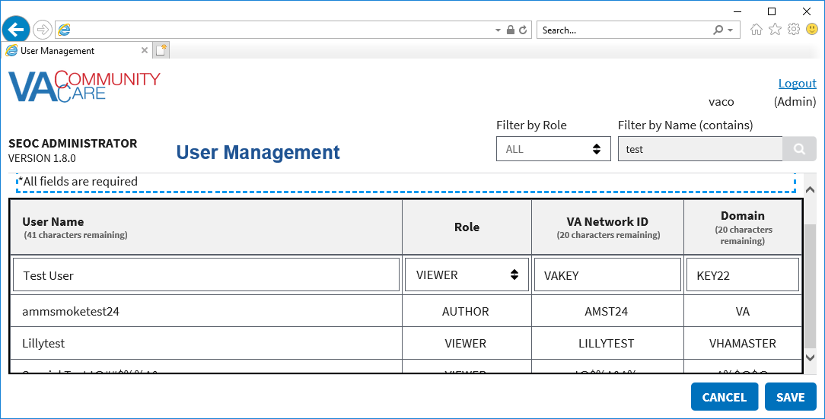

1. Edit the **User Name**, **Role**, **VA Network ID**, and **Domain** fields as needed.
2. Click **Save**. The updated user will display in the list of users.

### Add a New User

To delete a user from the User Management list, follow the steps listed below:

1. From the CC SEOC home page, click **Manage Users**. The **User Management** window displays.
2. Click **Add New User**.

Figure 10: Add New User Fields

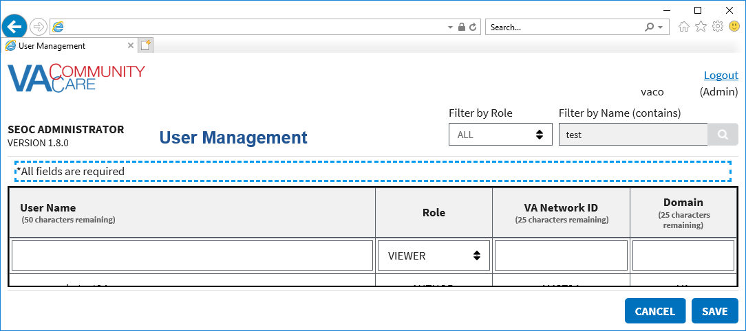

1. In the **User Name** field, enter the users name.
2. From the **Role** menu, select **Viewer**, **Analyst**, **Author**, **Publisher**, or **Administrator**.
3. In the **VA Network ID** field, enter the name of the VA network.
4. In the **Domain** field, enter the name of the domain.

## Managing Billing Codes

1. When updating the Billing Codes, SEOC will go into maintenance mode. SEOC users will be unable to update the system until the Admin has completed managing the billing codes.
2. Maintenance mode can be turned off by any Admin.
3. When you click on Return to SEOC list from Billing Code Management, it will automatically turn maintenance mode off.

To manage the billing codes in SEOC, follow the steps listed below:

1. From the CC SEOC home page, click **Manage Billing Codes**. The **Billing Code Management** window displays.

Figure 11: Billing Code Management

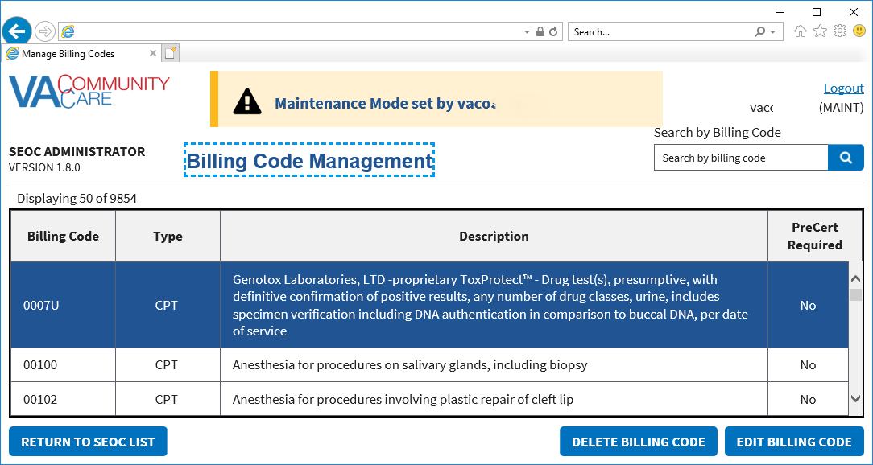

From the Billing Code Management window, you can delete billing codes and edit billing codes.

### Deleting Billing Codes

To delete billing codes in SEOC, follow the steps listed below:

1. From the CC SEOC home page, click **Manage Billing Codes**. The **Billing Code Management** window displays.
2. From the list of billing codes, select the code that you would like to delete.
3. Click **Delete Billing Code**.

Figure 12: Confirm Delete Billing Code Message

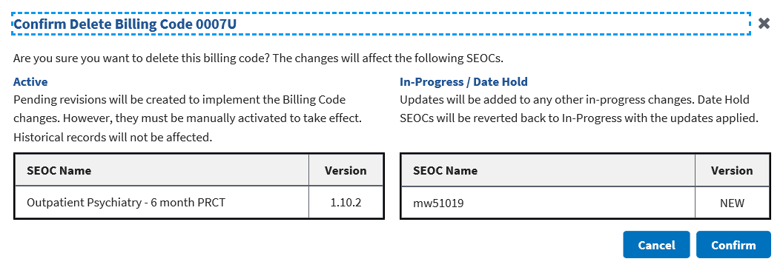

1. Verify that you want to delete the billing code listed, as the changes will affect the SEOCs listed in the Active and In-Progress tables.
2. Click **Confirm**. A message will display confirming that that the billing code was deleted and the billing code will no longer display in the list.

### Editing Billing Codes

To manage the billing codes in SEOC, follow the steps listed below:

1. From the CC SEOC home page, click **Manage Billing Codes**.
2. From the list of billing codes, select the code that you would like to edit.
3. Click **Edit Billing Code**. The **Edit Billing Code** fields display.

Figure 13: Edit Billing Code

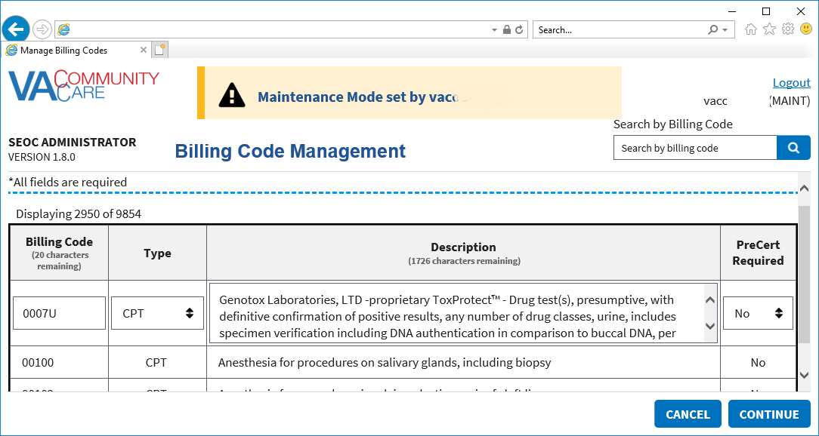

1. Update the **Billing Code** field as needed. The maximum number of characters for this field is 25.
2. From the **Type** field, select the correct option: **CPT**, **DRG**, **HCPCS**, **HIPPS**.
3. Update the **Description** field as needed. The maximum number of characters for this field is 2,000.
4. From the **PreCert Required** field, select the correct option: **NO** or **YES**.
5. Click **Continue**.

Figure 14: Edit Billing Code Confirmation Message

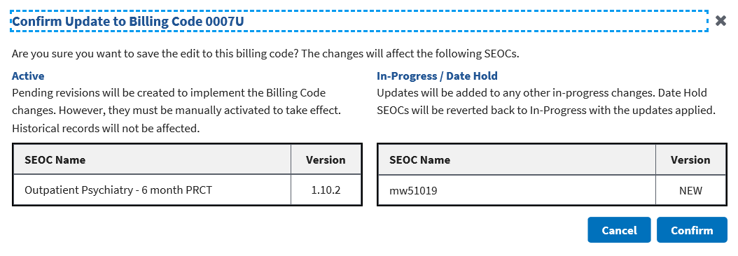

1. Verify that you want to delete the billing code listed, as the changes will affect the SEOCs listed in the Active and In-Progress tables.
2. Click **Confirm**. A confirmation message will display stating that the edits were made to the billing code.

## View SEOCs

### View a Selected SEOC

To view a SEOC from the SEOC list, follow the steps listed below:

1. From the CC SEOC home page, select the SEOC you would like to view.
2. Click **View Selected SEOC**. The **Standardized Episode of Care – Provider Information** page displays.

Figure 15: Standardized Episode of Care – Provider Information

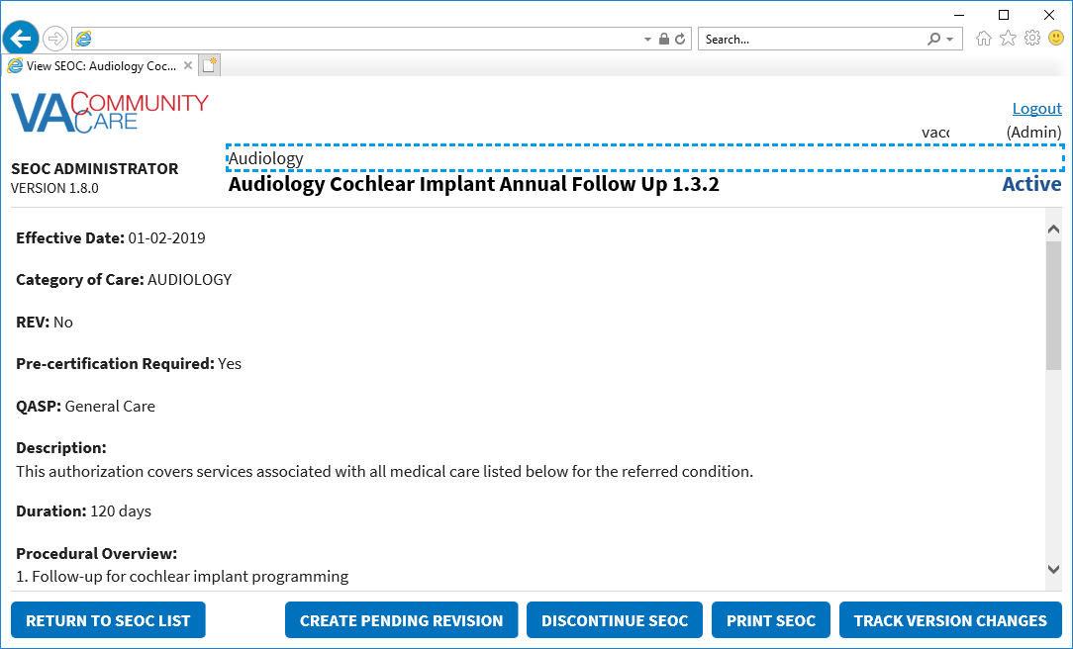

### Search for a SEOC by Name

To search for a SEOC, follow the steps listed below:

1. From the CC SEOC home page, enter the name of the SEOC in the **Filter by Name (contains)** field.

Figure 16: SEOC Filter Field

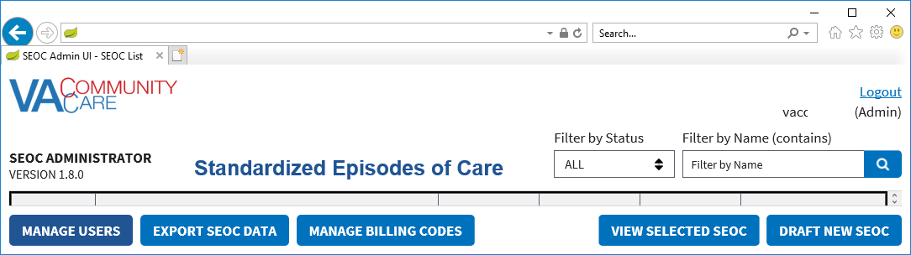

1. Click the **Search** button. The **Search SEOC Results** displays.

Figure 17: Search SEOC Results

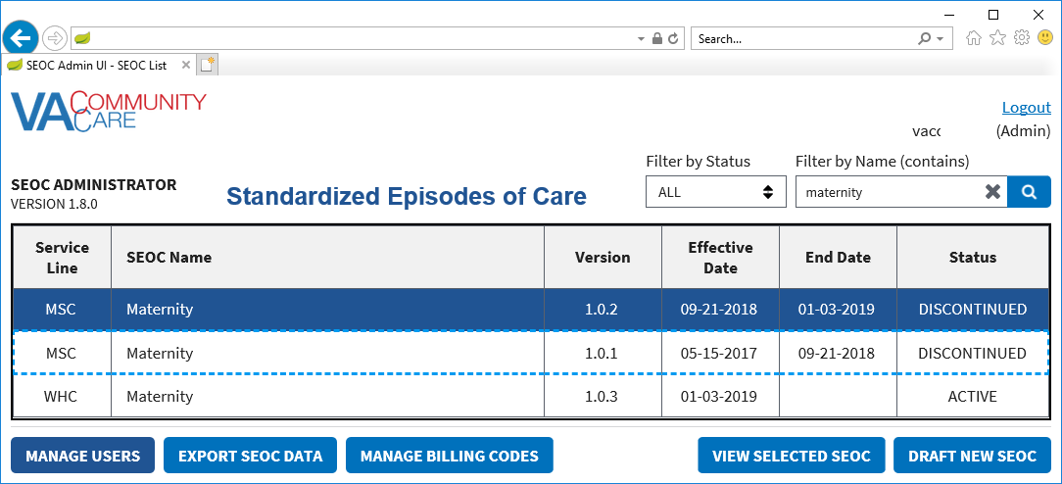

### Filter SEOCs by Status

To filter the list of SEOCs by status, follow the steps listed below:

1. From the CC SEOC home page, select **Filter By Status** menu.

Figure 18: Filter by Status Menu Options

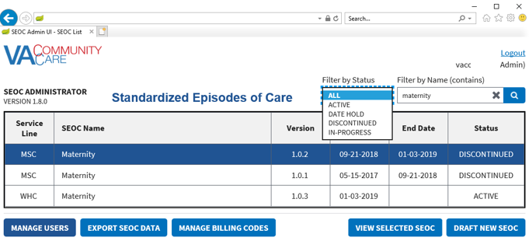

1. From the list of options select to filter by: **All**, **Active**, **Date Hold**, **Discontinued**, or **In-Progress**. The SEOC list refreshes to display the status filtered by.

### Discontinue a SEOC

To discontinue a selected Active SEOC, follow the steps listed below:

1. From the CC SEOC home page, select the SEOC you would like to discontinue.
2. Click **View Selected SEOC**, the **Standardized Episode of Care – Provider Information** page displays.
3. Click **Discontinue SEOC**. The discontinue SEOC confirmation dialog box displays.

Figure 19: Discontinue SEOC Confirmation



1. Click **Confirm Discontinue**. The **Standardized Episode of Care – Provider Information** page displays with the updated status of the SEOC.

Figure 20: Discontinued Status

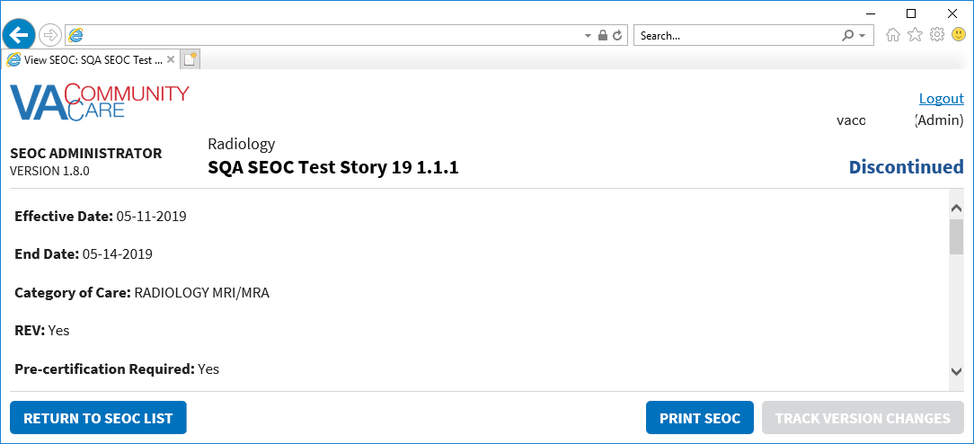

### Print a SEOC

To print a SEOC, follow the steps listed below:

1. From the CC SEOC home page, select the SEOC you would like to print.
2. Click **View Selected SEOC**, the **Standardized Episode of Care – Provider Information** page displays.
3. Click **Print SEOC**. The printed SEOC will display in another window. Print or save using local browser capabilities.

Figure 21: Printed SEOC Window

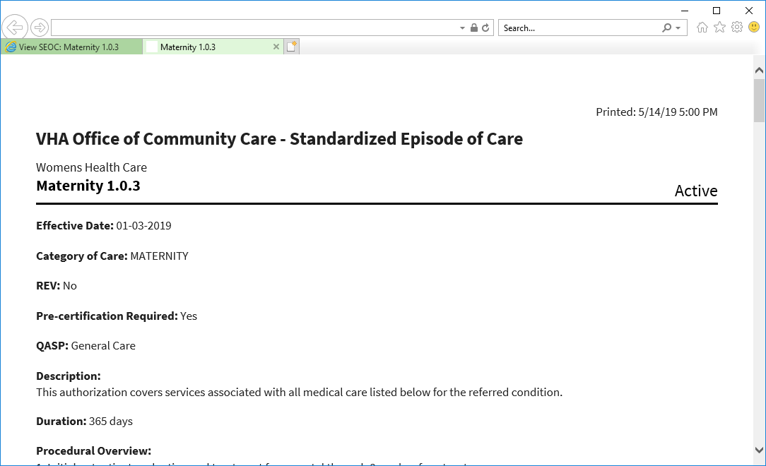

### Track Version Changes

To track the version changes of a SEOC, follow the steps listed below:

1. From the CC SEOC home page, select the SEOC you would like to track the version changes.
2. Click **View Selected SEOC**, the **Standardized Episode of Care – Provider Information** page displays.
3. Click **Track Version Changes**. The tracked changes display.

Figure 22: Tracked Version Changes

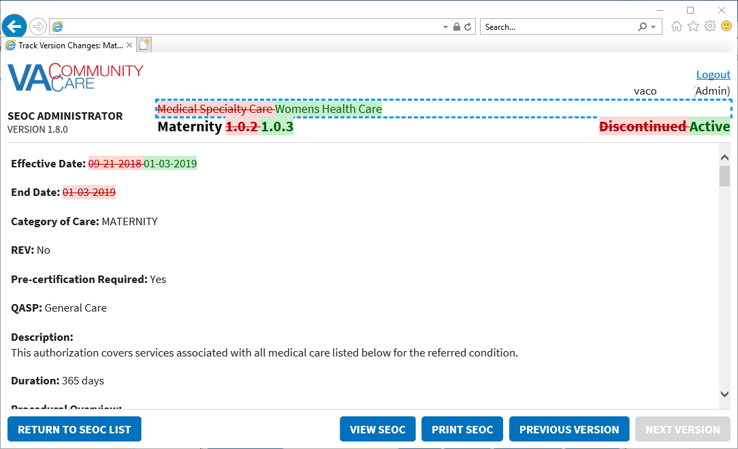

## Draft a New SEOC

To draft a new SEOC, follow the steps listed below:

1. From the CC SEOC home page, click **Draft New SEOC**. The **Draft SEOC: Name** window displays.

Figure 23: Draft SEOC: Name

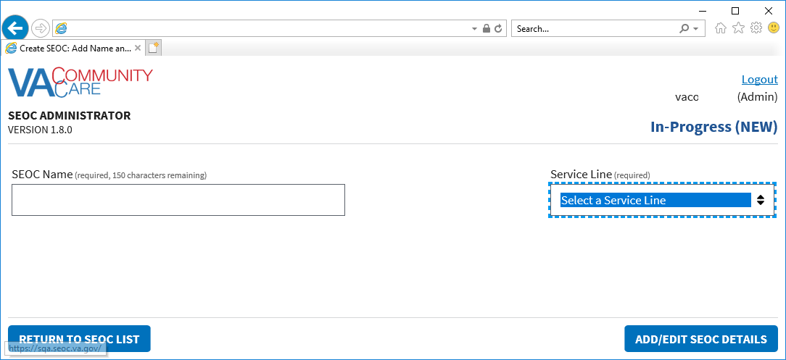

1. In the **SEOC Name** field, enter the name for the new SEOC (required field).
2. From the **Service Line** menu, select a service line (required field).
3. Click **Add/Edit SEOC Details**. The **Draft SEOC: Details** window displays.

Figure 24: Draft SEOC Details

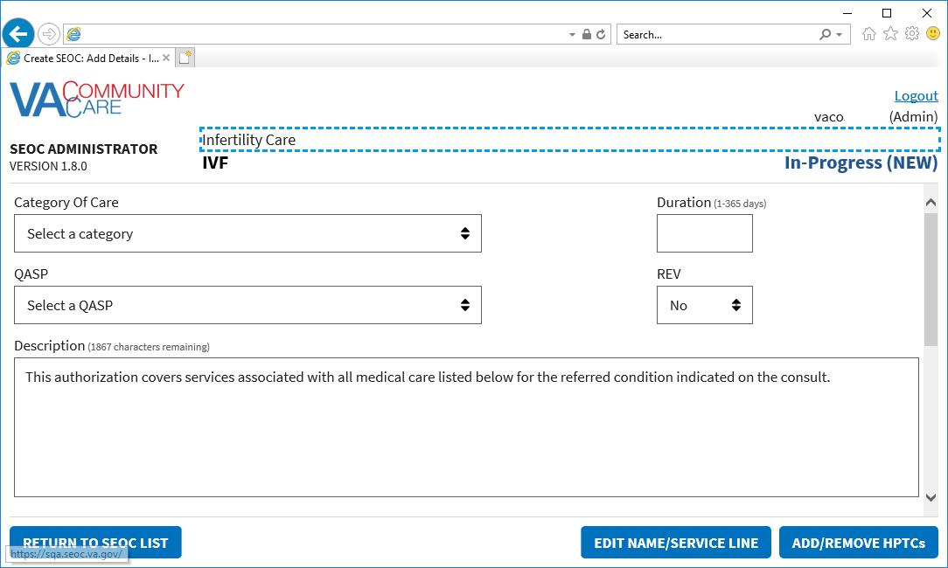

1. From the **Category of Care** drop-down menu, select the category.
2. In the **Duration (days)** field, enter the duration.
3. From the **PAL** drop-down menu, select **Yes** or **No**.
4. From the **QASP** drop-down menu, select a QASP:

* **Complimentary & Integrative Health Care**
* **General Care**
* **General Dental Care**
* **Primary Care**
* **Specialty Dental Care**

1. From the **PAL** drop-down menu, select **No** or **Yes**.
2. In the **Description** field, enter a description for the procedure. The maximum amount of characters for this field is 500.
3. In the **Procedural Overview** field, enter an overview on the procedure. The maximum amount of characters for this field is 5000.
4. In the **Additional Information** field, enter additional information regarding the procedure. The maximum amount of characters for this field is 2000.
5. Click **Add/Remove HPTCs**. The **Add/Remove HPTCs** window displays.

Figure 25: Add/Remove HPTCs

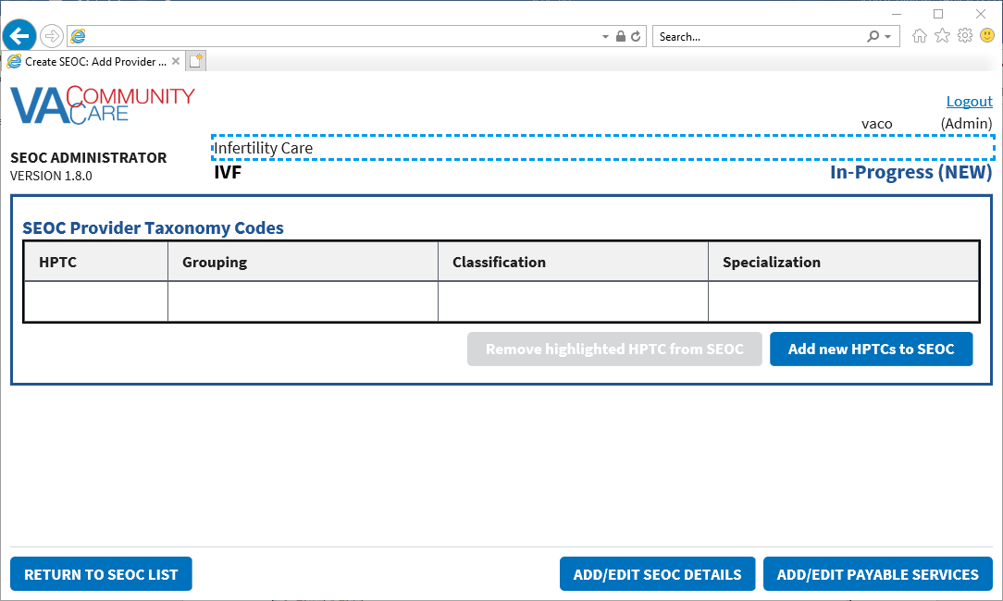

1. Click **Add new HPTCs to SEOC**. A list of provider taxonomy codes displays.

Figure 26: Provider Taxonomy Code List

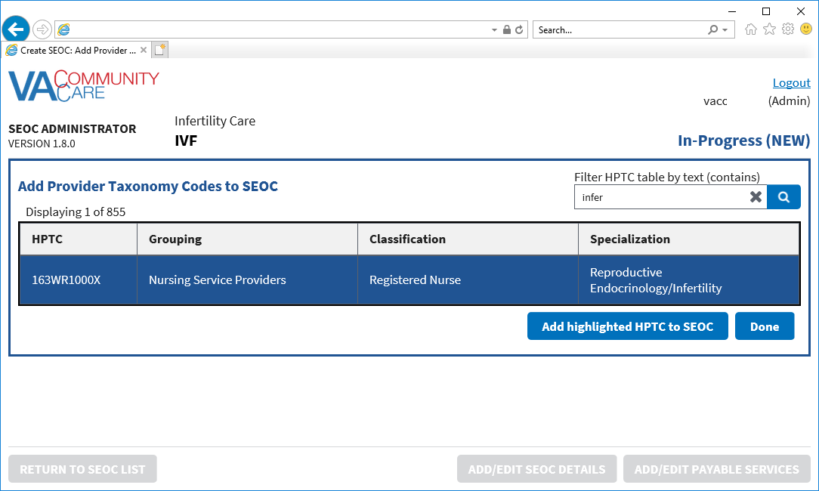

1. From the list of provider taxonomy codes select the HPTC to add to the SEOC. Another option is to use the **Filter HPTC table by text (contains)** field to filter the list of HPTCs and select the HPTCs from the filtered list.
2. You must add at least one HPTC to activate the SEOC.
3. Click **Add highlighted HPTC to SEOC**. A confirmation message displays telling you the HPTC was added.
4. Click **Done**. The selected HPTC displays.

Figure 27: Selected HPTC

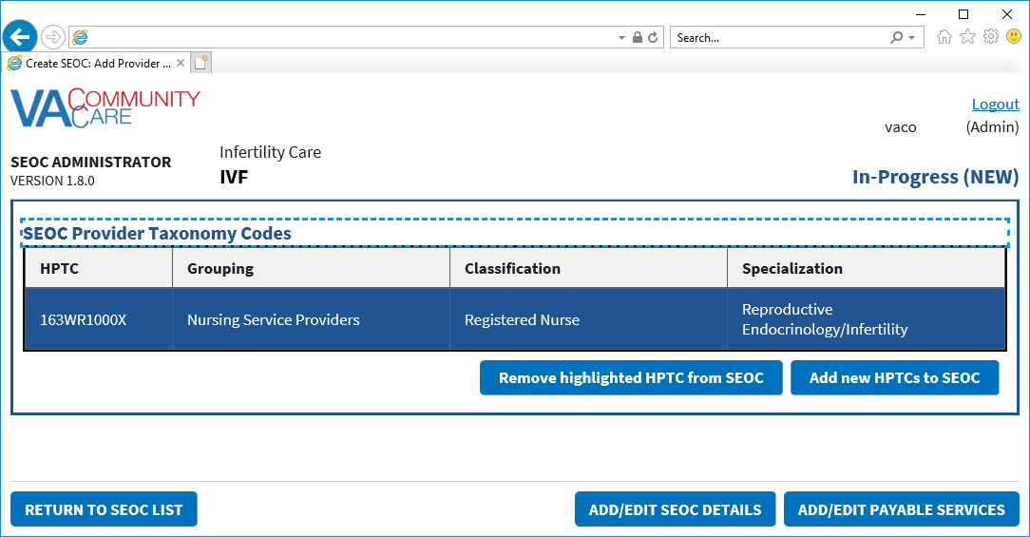

1. Click **Add/Edit Payable Services**. The **Draft SEOC: Payable Services** window displays.

Figure 28: Draft SEOC: Payable Services

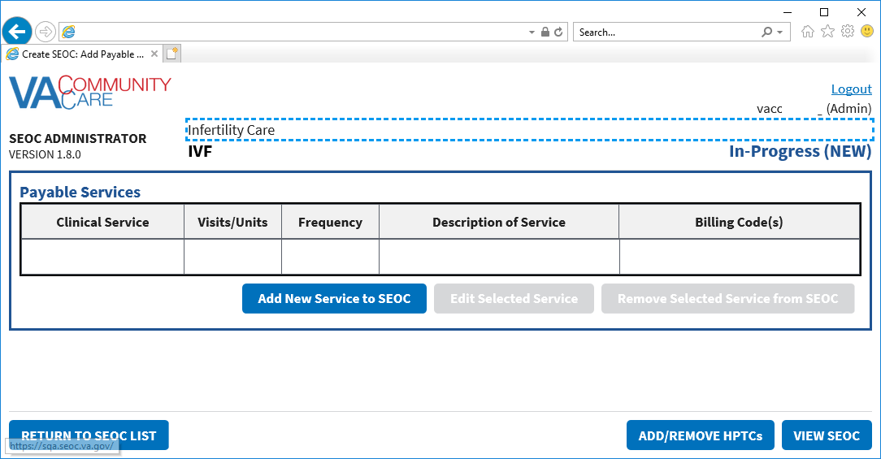

1. Click **Add New Service to SEOC**. The **Draft SEOC: Add Payable Service** section displays at the bottom of the page.

Figure 29: Draft SEOC: Add Payable Service

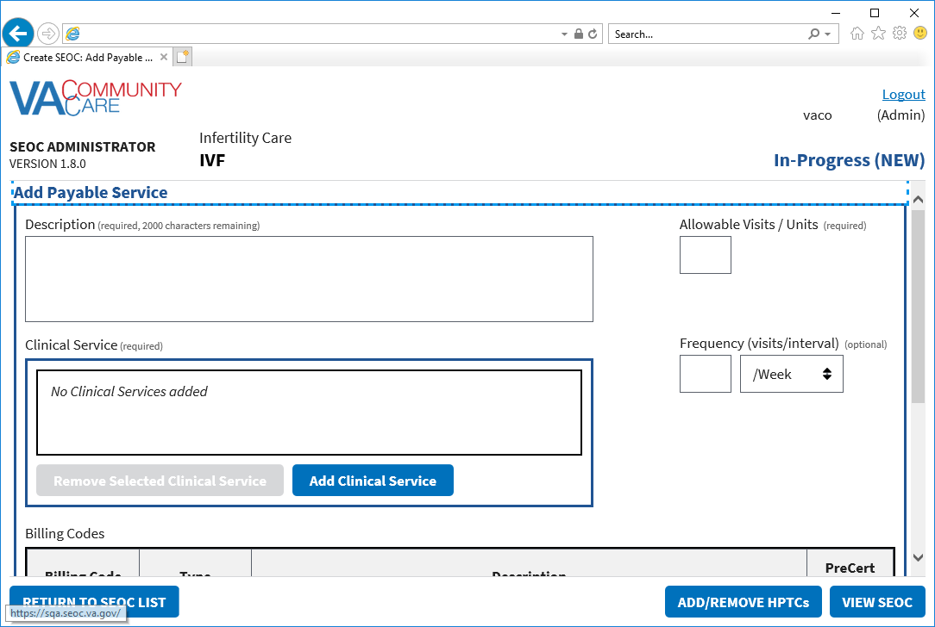

1. In the **Description** field, enter a description for the payable service (required field).
2. In the **Allowable Visits** field, enter the number of allowed visits.
3. From the **Clinical Service** section, click **Add Clinical Service** (required field).

Figure 30: Manage Clinical Services for Payable Service

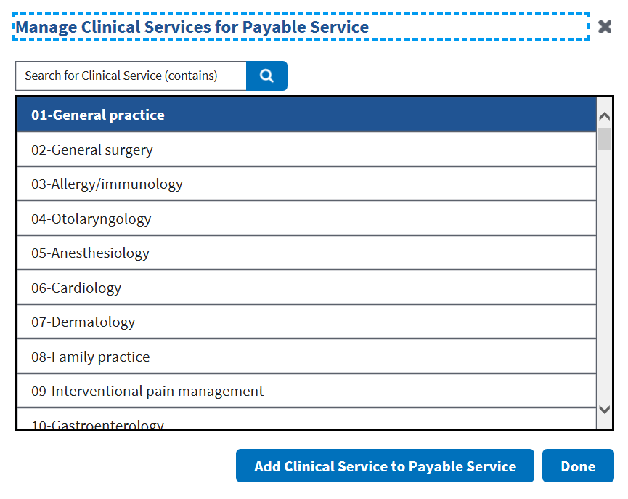

1. From the list of clinical services, select the service.
2. Click **Add Clinical Service to Payable Service**. A confirmation message displays telling you the clinical service was added.
3. Click **Done**. The clinical service displays in the **Clinical Service** field.

Figure 31: Clinical Service Field

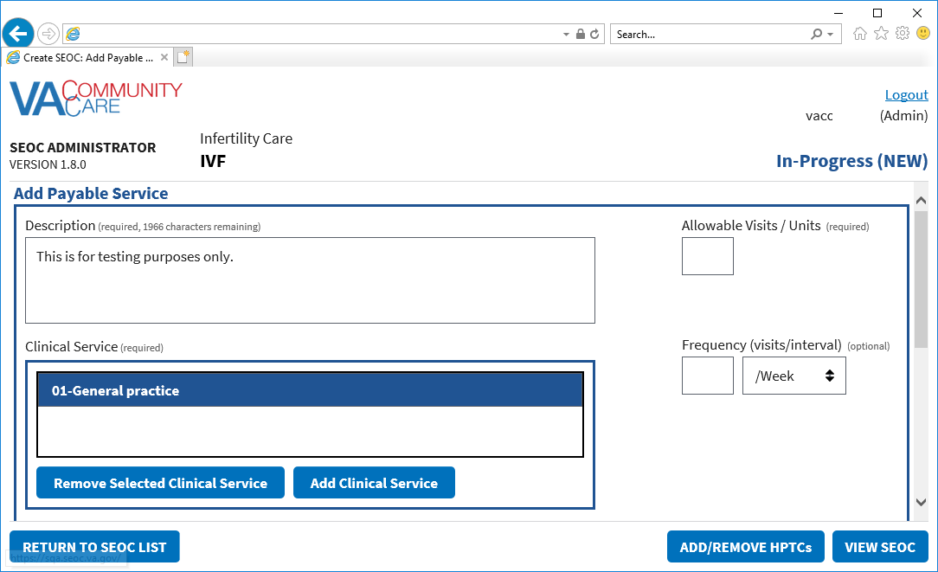

1. In the **Frequency (visits/period)** field, enter the number of visits and select if it is per week, month, or year (required field).
2. Click **Add New Billing Code to Service**. The **Draft SEOC: Add Billing Code** dialog box displays.

Figure 32: Draft SEOC: Add Billing Code

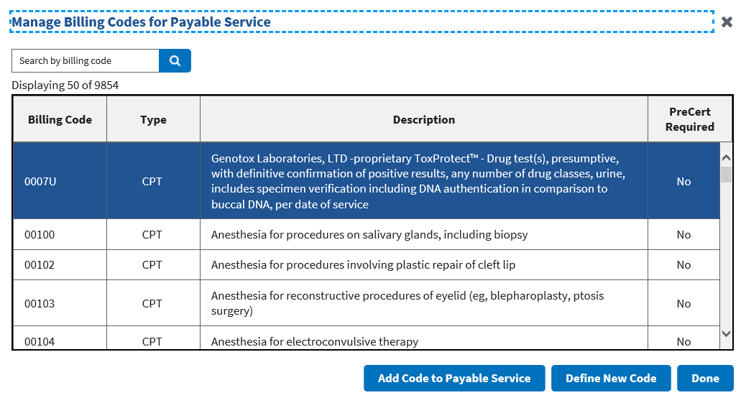

1. Select the billing code option for the Payable Service. If **No Code Required** is selected, the **PreCert Required** field defaults to **Yes**. If the billing code is not listed, proceed to the substeps below.
2. If the billing code is not listed, select **Define New Code**. The **Define New Code** dialog box displays.

Figure 33: Define New Code

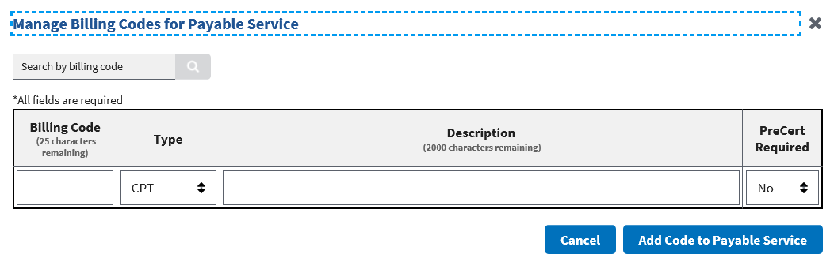

1. In the **Billing Code** field, enter the new code. The maximum number of characters for this field is 25.
2. From the **Type** field, select the correct option: **CPT**, **DRG**, **HCPCS**, **HIPPS**.
3. In the **Description** field, enter a description for the new code. The maximum number of characters for this field is 2,000.
4. From the **PreCert Required** field, select the option: **NO** or **YES**.
5. Click the **Add Code to Payable Service**. If you attempt to duplicate a billing code for the payable service, you will receive an error message.

Figure 34: Duplicate Billing Code Message

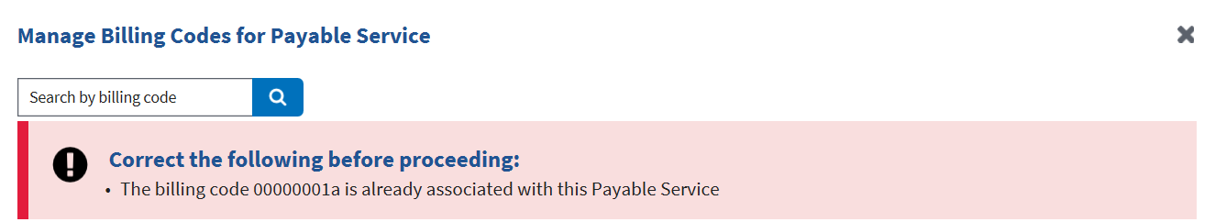

1. Click **Done**. The **Payable Services** displays.

Figure 35: Billing Code

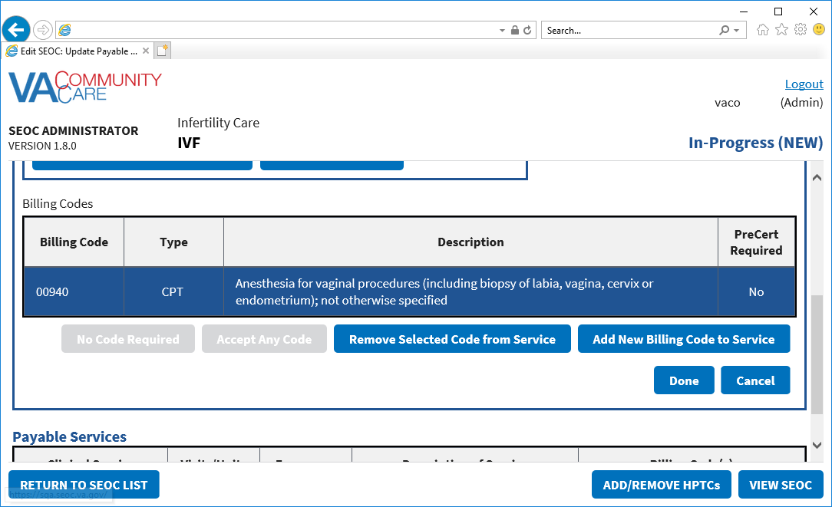

1. Click **Done**. The **Payable Services** window displays.

Figure 36: Payable Services

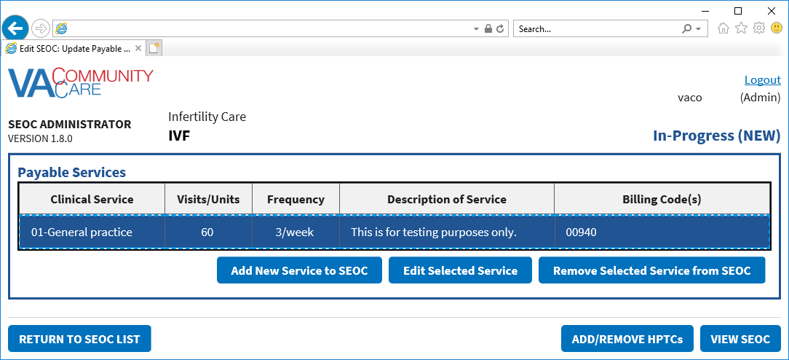

1. Click **View SEOC**. The **Draft SEOC View** displays.

Figure 37: Draft SEOC View

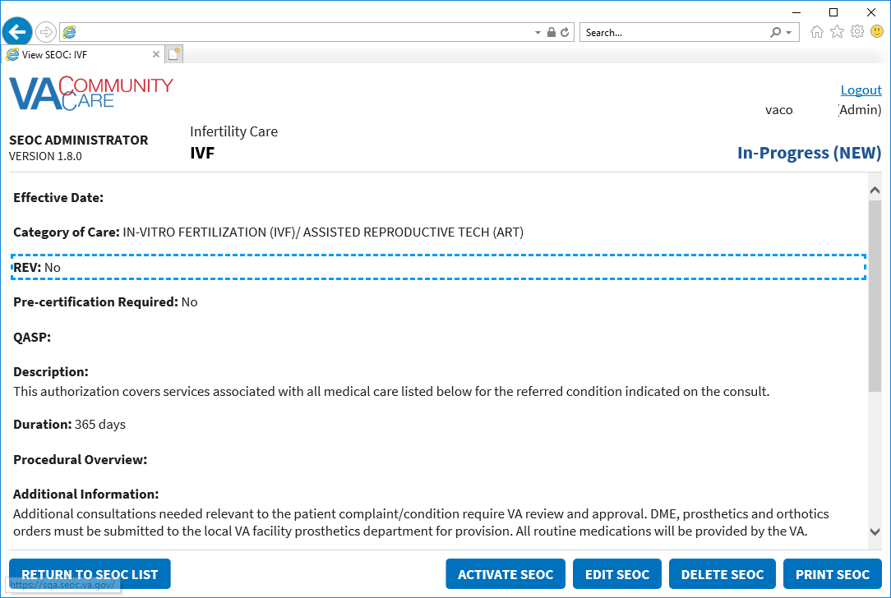

### Edit an In-Progress SEOC

1. If a user attempts to edit a SEOC that another user is already editing, the user will receive a message stating that the request can’t be processed.
2. If a user attempts to edit a SEOC while the system is in maintenance mode for Billing Code Management, the user will receive a message stating that the request can’t be processed.

To edit a SEOC that is currently marked as In-Progress, follow the steps listed below:

1. From the CC SEOC home page, select the SEOC you would like to edit.
2. Click **View Selected SE**OC, the **Standardized Episode of Care – Provider Information** page displays.
3. Click **EDIT SEOC**. The **In-Progress SEOC Name** window displays.
4. Edit the fields that need to be updated.
5. Click **View SEOC** to confirm the edits.

### Activate an In-Progress SEOC

To activate a SEOC that is currently marked as In-Progress, follow the steps listed below:

1. From the CC SEOC home page, select the SEOC you would like to activate.
2. Click **View Selected SE**OC, the **Standardized Episode of Care – Provider Information** page displays.
3. Click **Activate SEOC**. The **SEOC Activation Effective Date** dialog box displays.

Figure 38: SEOC Activation Effective Date

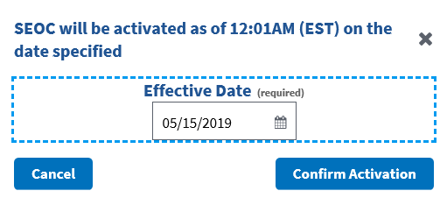

1. In the **Effective Date** field, enter the date to activate the SEOC.
2. Click **Confirm Activation**. The status will update and display as **Date Hold**.

Figure 39: Activation Status

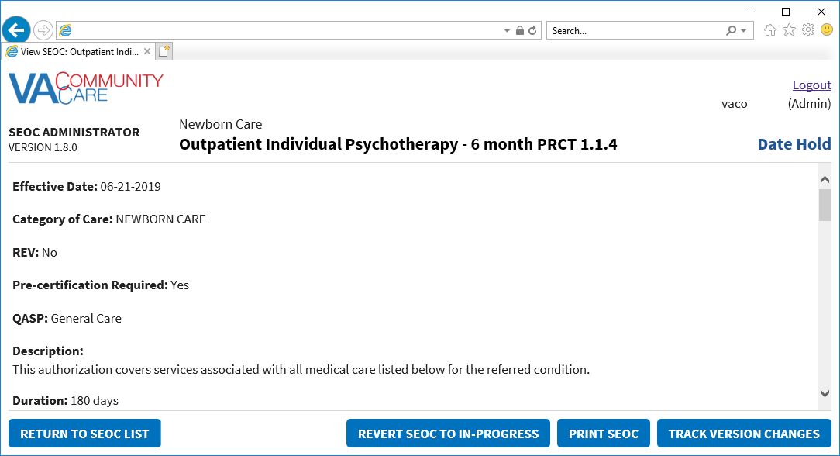

### Delete an In-Progress SEOC

To delete a SEOC that is currently marked as In-Progress, follow the steps listed below:

1. From the CC SEOC home page, select the draft SEOC you would like to delete.
2. Click **View Selected SE**OC, the **Standardized Episode of Care – Provider Information** page displays.
3. Click **Delete SEOC**. The **Confirm Deletion** dialog box displays.

Figure 40: Confirm Deletion



1. Click **Confirm Deletion**. The SEOC is deleted from the SEOC List.

## Pending Revisions

### Create a Pending Revision

To create a pending revision to an existing SEOC, follow the steps listed below:

1. From the CC SEOC home page, select the active SEOC you would like to create a pending revision.
2. Click **View Selected SE**OC, the **Standardized Episode of Care – Provider Information** page displays.
3. Click **Create Pending Revision**. The **Pending Revision: Name** window displays.

Figure 41: Pending Revision: Name

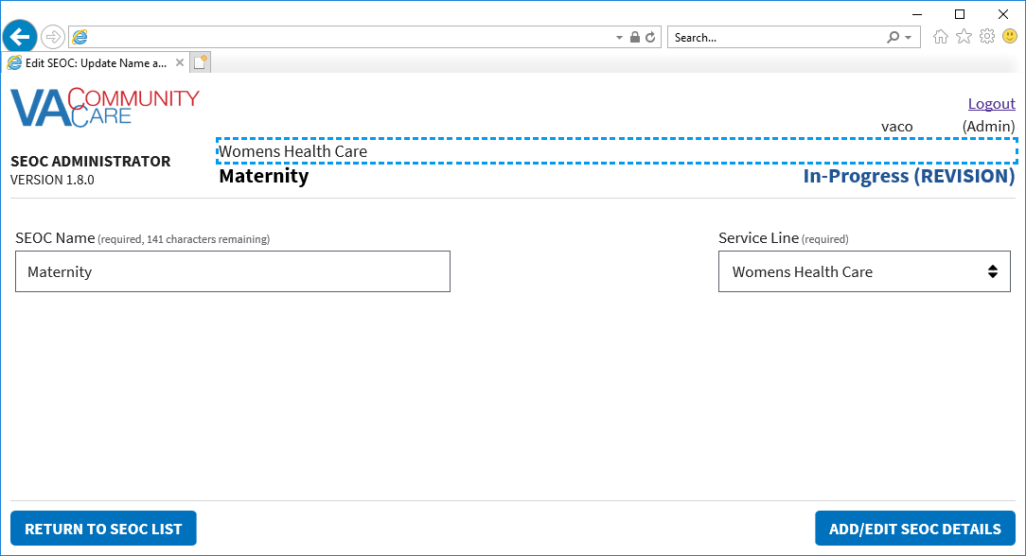

1. Update the SEOC name and service line as needed.
2. Click **Add/Edit SEOC Details**. The **Pending Revision: Details** window displays.

Figure 42: Pending Revision: Details

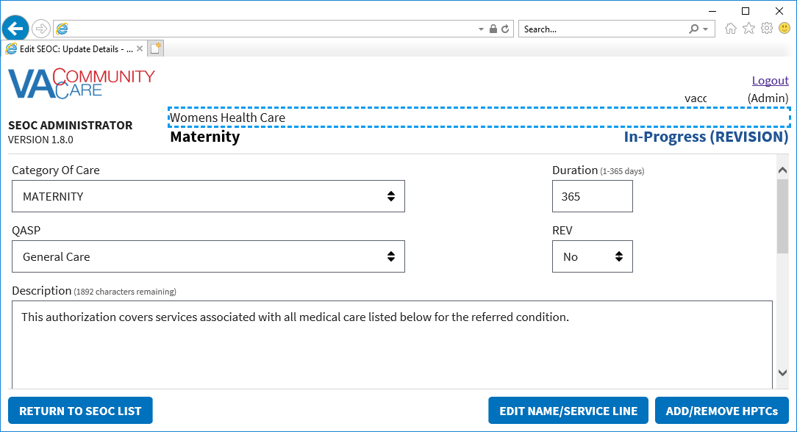

1. Update the details for the SEOC as needed.
2. Click **Add/Remove HPTCs**. The **Pending Revision: SEOC Provider Taxonomy Codes** window displays.

Figure 43: Pending Revision: SEOC Provider Taxonomy Codes

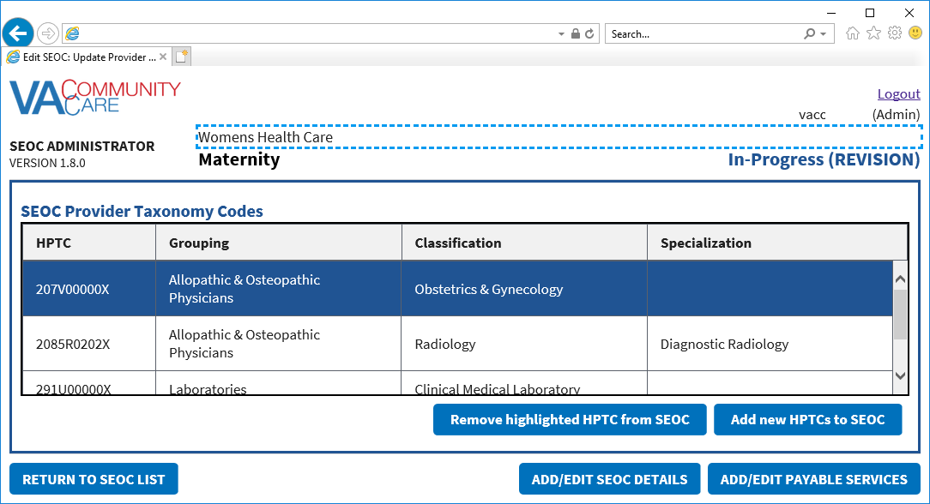

1. Update the taxonomy codes as needed.
2. Click **Add/Edit Payable Services**. The **Pending Revision: Payable Services** window displays.

Figure 44: Pending Revision: Payable Services

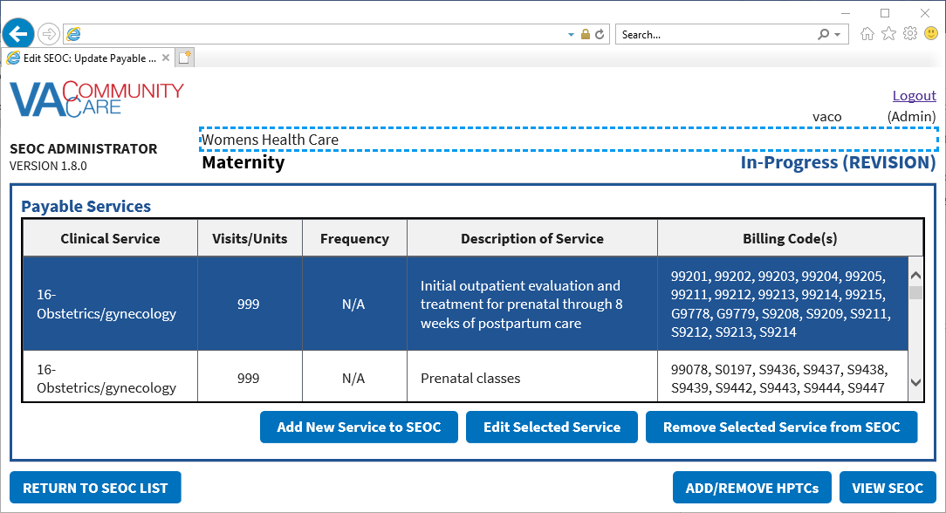

1. Update the Payable Services as needed.
2. Click **View SEOC**. The Pending Revision status will display in the window.

Figure 45: Pending Revision Status

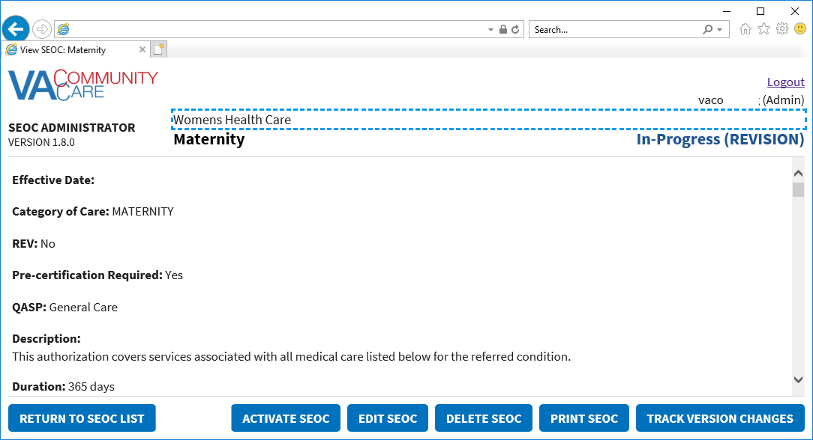

1. Click **Return to SEOC List**. The pending revision will display in the list of SEOCs.

Figure 46: Pending Revision Displayed in SEOC List

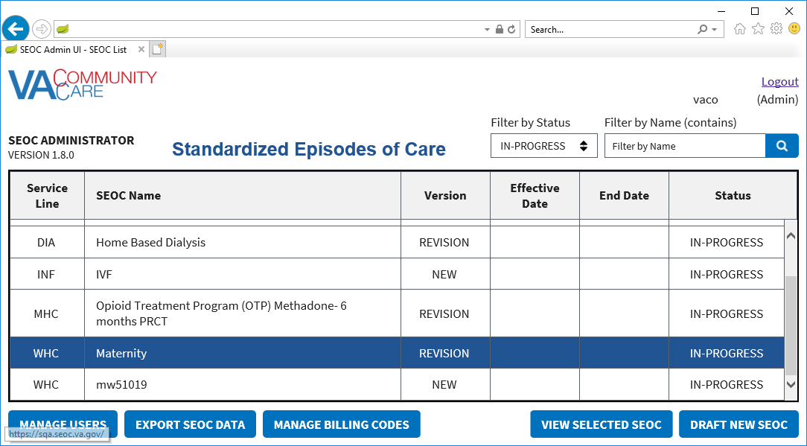

### Activate a Pending Revision

To activate a pending revision, follow the steps listed below:

1. From the CC SEOC home page, select the pending revision SEOC that you would like to activate.
2. Click **View Selected SE**OC, the **Standardized Episode of Care – Provider Information** page displays.
3. Click **Activate SEOC**.

Figure 47: Pending Revision Activation Confirmation Message

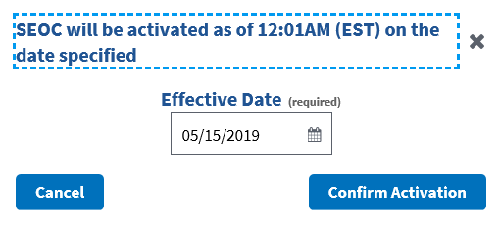

1. In the **Effective Date** field, enter the date to activate the SEOC.
2. Click **Confirm Activation**. The status will update and display as **Date Hold**.

Figure 48: Date Hold Status

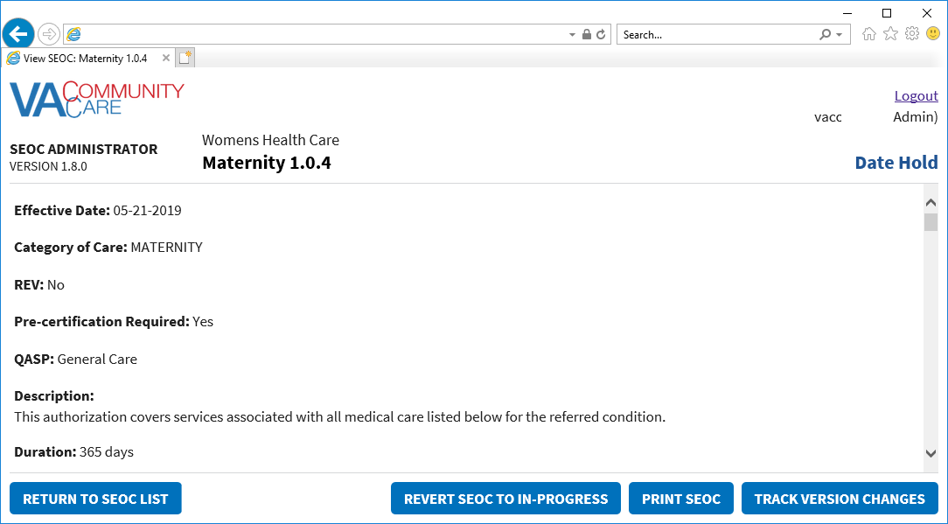

1. Click **Return to SEOC List**. The pending revision that you just activated will display as **Date Hold** in the list of SEOCs.

### Revert SEOC to In-Progress

If you need to revert the selected SEOC to In-Progress, follow the steps listed below:

1. From the CC SEOC home page, select the SEOC with a Date Hold status that you would like to revert to In-Progress.
2. Click **View Selected SE**OC, the **Standardized Episode of Care – Provider Information** page displays.
3. Click **Revert SEOC to In-Progress**. The **Revert SEOC to In-Progress** dialog box displays.

Figure 49: Revert SEOC to In-Progress



1. Click **Confirm**.

## Payable Service List

### View Payable Services

To view the payable services for a selected SEOC, follow the steps listed below:

1. From the CC SEOC home page, select the SEOC you would like to view the payable services for.
2. Click **View Selected SE**OC, the **Standardized Episode of Care – Provider Information** page displays.
3. Scroll to the bottom of the page to view the Payable Services list.

Figure 50: Standardized Episode of Care – Payable Services

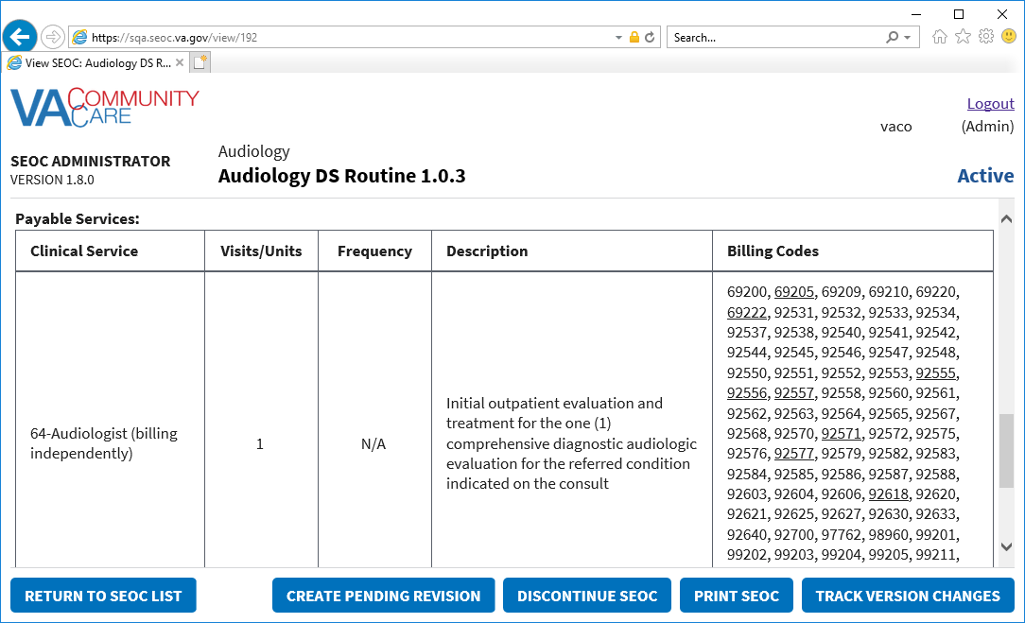

### Delete Payable Service

To delete payable services for a selected SEOC, follow the steps listed below:

1. From the CC SEOC home page, select the SEOC you would like to view the payable services for.
2. Click **View Selected SE**OC, the **Standardized Episode of Care – Provider Information** page displays.
3. From the **Standardized Episode of Care – Provider Information** page, click **Create Pending Revision**. The **Draft SEOC Name** window displays.
4. Click **Add/Edit SEOC Details**. The **Draft SEOC Details** window displays.
5. Click **Add/Remove HPTCs**. The **Add/Remove HPTCs** window displays.
6. Click **Add/Edit Payable Services**. The **Draft SEOC Payable Services** window displays.
7. From the list of payable services, select the payable service that you would like to delete.
8. Click **Remove Selected Service from SEOC**. A message will display confirming that you would like to delete the payable service from the SEOC.

Figure 51: Payable Service Confirm Deletion

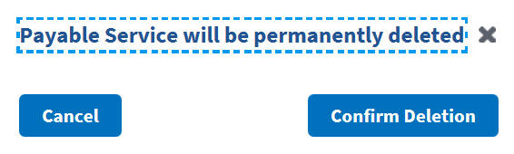

1. Click **Confirm Deletion**. The payable service is deleted from the list.

## Exporting SEOC Data

To export the data for a selected SEOC, follow the steps listed below:

1. From the CC SEOC home page, select the SEOC you would like to export the data for.
2. Click **Export SEOC Data** to download the SEOC. The file will be exported to a JSON file.

Figure 52: Export SEOC Download Message



1. Select to save the downloaded file.
2. Please refer to Appendix A for additional steps on converting the JSON file into an Excel file.

# Troubleshooting

Users may encounter the following errors while using the SEOC UI.

Table 2: SEOC Error Codes with Descriptions

| Error Code | Description |
| --- | --- |
| 204 | No Content Found |
| 401 | Unauthorized |
| 403 | Forbidden |
| 404 | Not Found |

# Acronyms and Abbreviations

| Acronym | Definition |
| --- | --- |
| CAC | Clinical Application Coordinators |
| CC | Care Coordination |
| CCAD | Community Care Agile Development |
| CDW | Corporate Data Warehouse |
| CID | Clinically Indicated Date |
| CPRS | Computerized Patient Record System |
| HEC | Health Eligibility Center |
| HPTC | Healthcare Provider Taxonomy Code |
| JSON | JavaScript Object Notification |
| NSD | National Service Desk |
| OIT | Office of Information and Technology |
| PCP | Primary Care Physician |
| SAR | Secondary Authorization Request |
| SEOC | Standardized Episode of Care |
| VA | Department of Veterans Affairs |
| VDL | VA Software Document Library |
| VistA | Veterans Health Information Systems and Technology Architecture |

1. JSON Instructions
2. The steps outlined below are for Outlook 2016.

To convert the SEOC JSON file to an Excel file, follow the steps listed below:

1. Download the SEOC JSON file to your desktop.
2. Open a blank workbook in Excel 2016.
3. Click the **Data** tab, then **Get Data** > **From File** > **From JSON**. The **Import Data** window displays.

Figure 53: Import Data Window

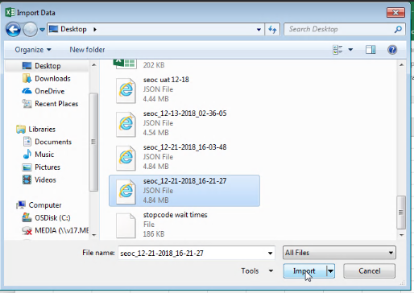

1. Select the JSON file you downloaded and click **Import**. Excel will open the file in the Query Editor.

Figure 54: Query Editor

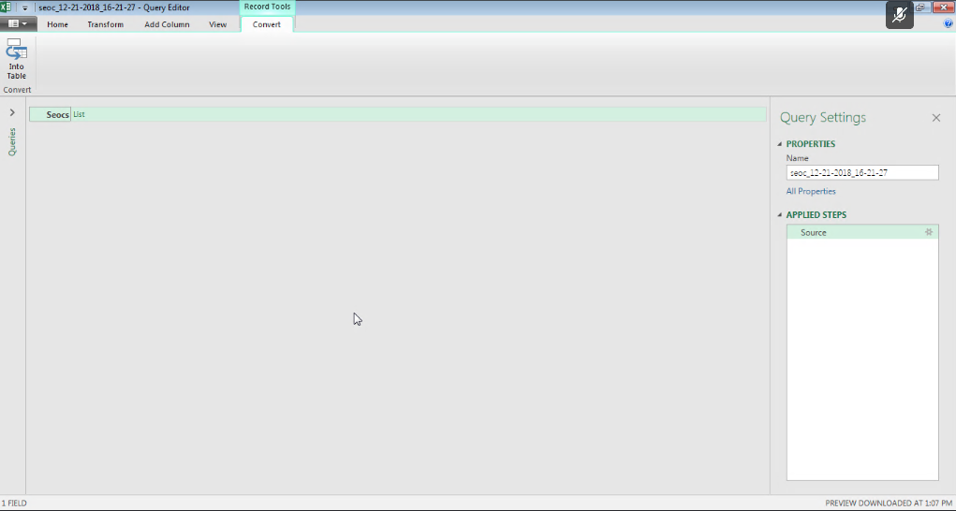

1. Click the **List** header to the right of **Seocs** to display a list of records.

Figure 55: List of Records

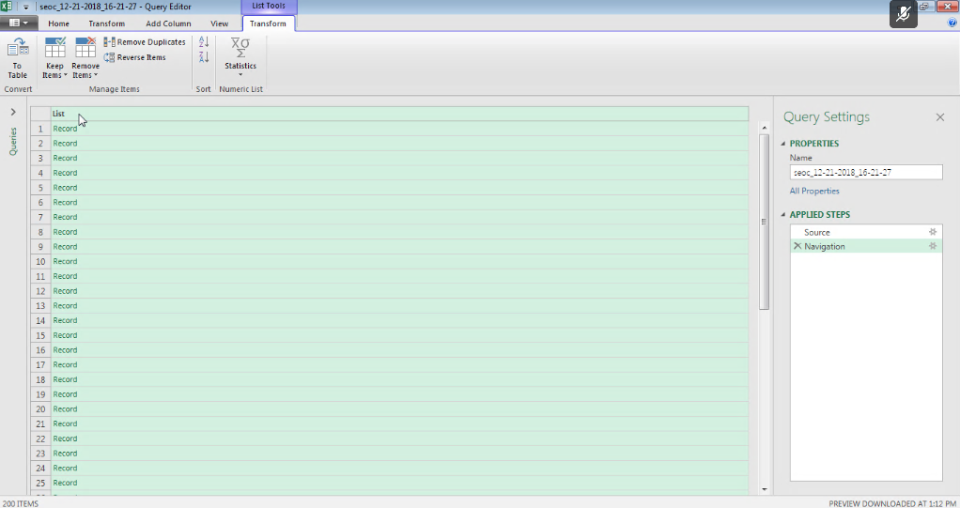

1. From the **Transform** tab, click the **Convert To Table** icon and click **OK**. The **To Table** dialog box displays.

Figure 56: To Table Dialog Box

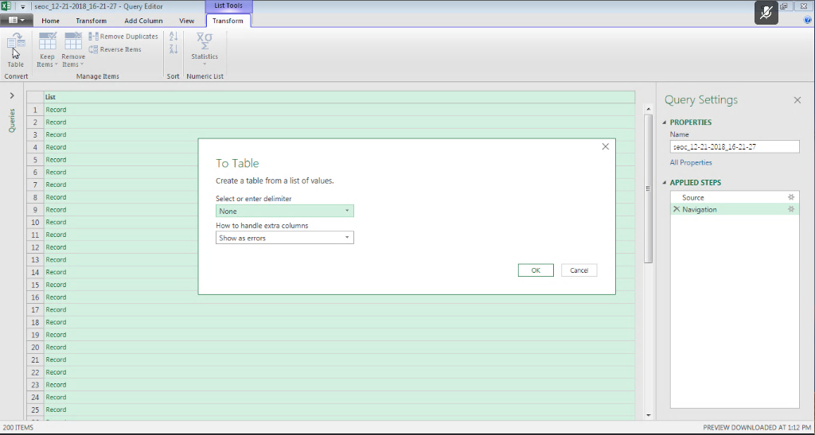

1. From the **To Tabl**e dialog box keep the default selections and click **OK**.
2. Click on the expand icon (<-||->) to the right of the **Column1** header to display the **Search Columns to Expand** dialog box.

Figure 57: Search Columns to Expand Dialog Box

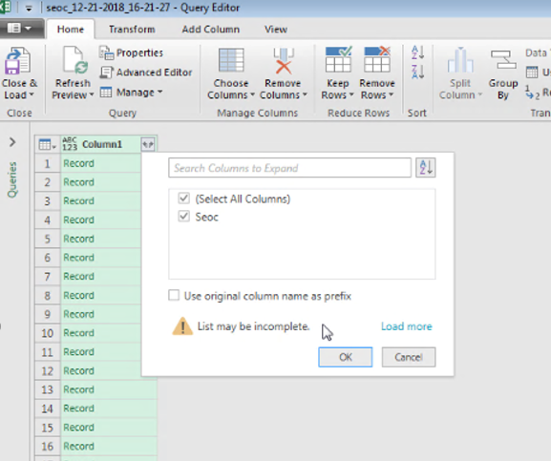

1. De-select the **Use original column name as prefix** check box.
2. Click **OK**.
3. Click on the expand icon (<-||->) to the right of the **Seoc** header to display the **Search Columns to Expand** dialog box.

Figure 58: Search Columns to Expand

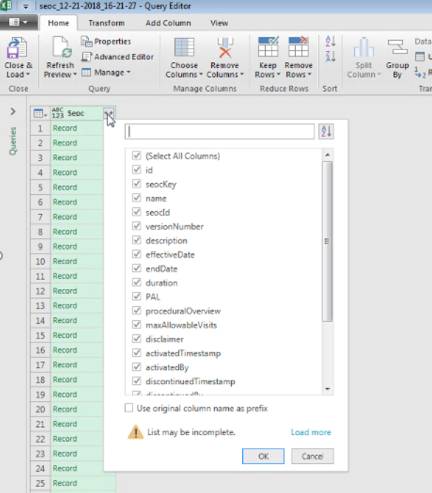

1. Uncheck the **Use original column name as prefix** check box.
2. Click **OK**. The fields in the SEOC table will be expanded to columns as shown below.

Figure 59: Expanded SEOC Fields

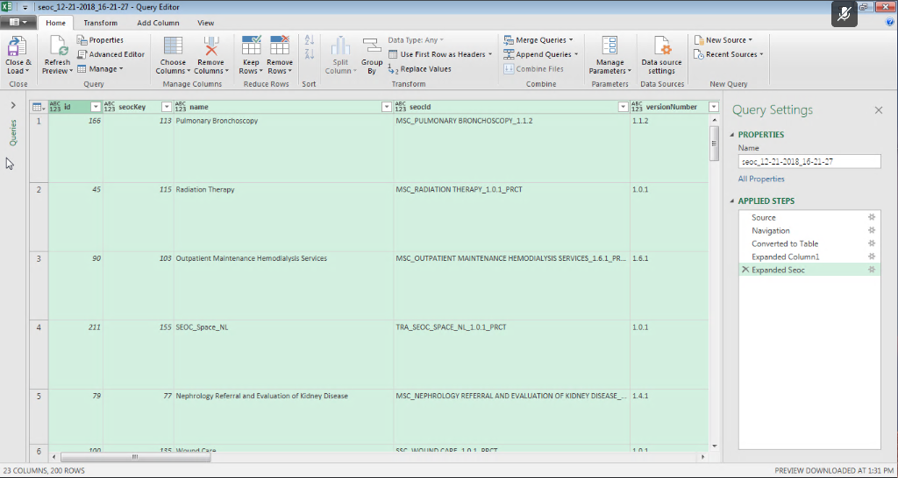

1. Scroll right to the **services** column, click on the expand icon, and select **Expand to New Rows** to display the records.

Figure 60: Expand to New Rows Menu Option

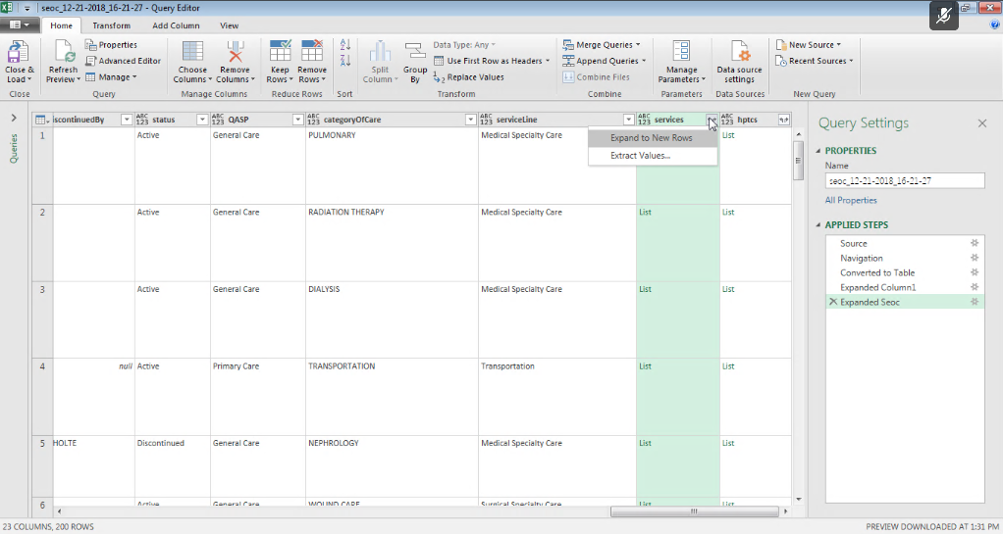

1. Click the expand icon again and press **OK** to expand the Payable Services fields into columns.

Figure 61: Payable Services Columns

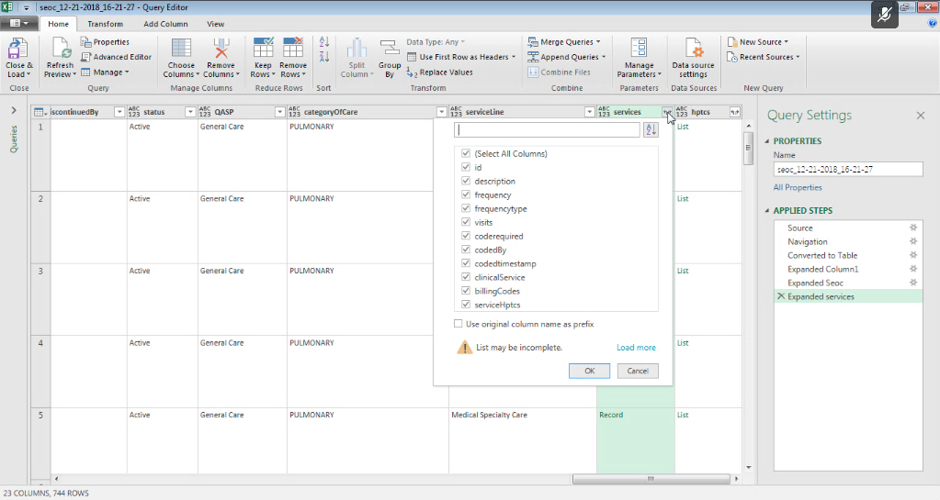

1. Scroll right to the **billingCodes** column and repeat the last two steps to expand the **Billing Code** fields into columns.

Figure 62: Billing Code Columns

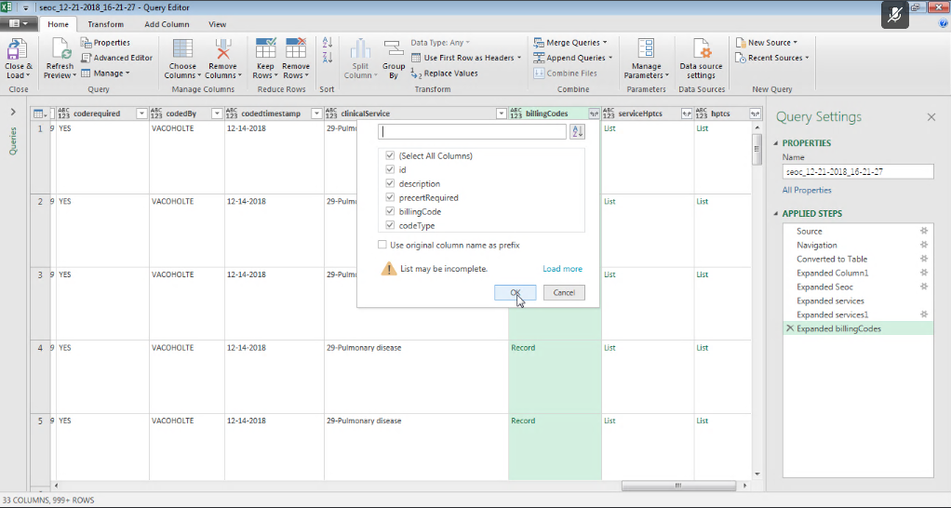

1. Optional - Repeat the last two steps again for the serviceHptcs column if you want to see the cross-walked HPTCs that are sent for each Payable Service.
2. Scroll right and repeat the last two steps again for the hptcs column to expand the HPTC fields that were assigned to each SEOC.

Figure 63: Expanded HPTC Fields

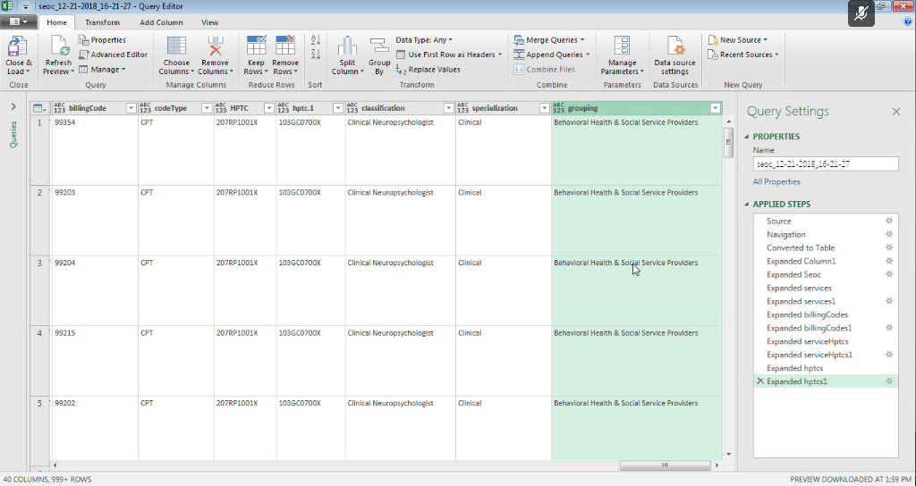

1. Click the **Close & Load** option at the left of the ribbon to create load the imported data into a spreadsheet tab.

Figure 64: Imported Data

